**A MAJORPROJECT REPORT**

**ON**

Online Book Store

**BACHELOR OF COMPUTER APPLICATIONS**

Degree

Session 2020-21





**DEPARTMENT OF BCA**

**BEACON INSTITUTE OF TECHNOLOGY**

**MEERUT**



**SUBMITTED TO** **SUBMITTED BY**

Mrs. Lucky Berwal Chetan Gupta (180968106025)

**TO WHOM IT MAY CONCERN**

This is to certify that Chetan Gupta from Department of BCA, Beacon Institute of Technology, and Meerut has carried out the project at our organization.

Under training period, they have worked on the project entitled Online Book Store under the guidance of Mrs. Lucky Berwal. My role in the project was full-stack developer.

The work carried by him/her is satisfactory and wish his /her all the best for future assignments.

Authorized Signatory

Name………………….

Designation ……………….

|  |
| --- |
|  |

**TABLE OF CONTENTS**

(i) Acknowledgement

(ii) Declaration/ Certificate

(iii) Abstract

1. Introduction

1.1Existing system and its limitations/ Problem Statement

1.2 Proposed system – Scope and Objective

1.3 Organization of the project report in accordance with SDLC – chapter overview

2. Process Model

2.1 Model Description

2.2 Architecture

2.3 Development Methodology

3. Requirement Analysis

3.1 Requirement Elicitation

3.1.1 Use Case Scenarios

3.1.2 Use Case Diagrams

3.2 Feasibility Study

3.2.1 Technical Feasibility (based on hardware & software availability)

3.2.2 Operational Feasibility (based on ease of understanding and use)

3.2.3 Economical Feasibility (based on cost estimation)

3.3 Requirement Analysis of the Proposed System

3.3.1 Context Level DFD

3.3.2 Level-1 DFDs

3.3.3 Level-2 DFDs

3.3.4 Data Dictionary

3.3.5 E-R Diagrams

3.4 Software Requirement Specifications (SRS)

3.5 Hardware and Other Requirements

4. System Design

4.1 Design Approach – Top Down/ Bottom Up (Whichever applicable)

4.2 Design Methodology – Function Oriented/ Object Oriented

4.3 Module and Sub-Module Description

4.4 User Interface Design - Snapshots

5. Coding

5. Hard Code

6. Testing

6.1 Methodology of Testing used in the project

6.2 Test Cases

6.3 Steps of Testing of Module

7. Implementation/Maintenance

7.1 Installation Procedure

7.2 Do and Don’ts

8. Conclusion

9. Limitations and Future Works

10. Bibliography and References

Page No.

6

6

6

8

9

9

9

9

11

11

12

13

14

14

14

14

15

15

15

16

17

20

21

21

22

22

22

23

24

31

31

47

47

47

48

49

49

64

65

66

67

**ACKNOWLEDGEMENT**

Praise and thanks to Almighty God for the success of this project work. It is essential at this point to acknowledge with thanks those who have made useful contributions to facilitate the successful accomplishment of this academic task.

We wish to express or reserved gratitude to our supervisor, Mrs. Lucky Berwal for his comments and suggestions for expanding of knowledge on this our research work.

Our deepest appreciation goes to our friends and course mates and everyone who helped us throughout the course of writing this project.

Finally, while we acknowledge the contribution of all, we claim total responsibility for whatever shortcomings the project may have or contain. Perfection belongs only to Almighty God.

**Chetan Gupta**

**ABSTRACT**

This project is a web based onlinebook store for an existing shop. The project objective is to deliver the online book shopping application into web platform. This project is an attempt to provide the advantages of online book shopping to customers of a real shop. It helps buying the products in the shop anywhere through internet by using browser. Thus the customer will get the service of online book shopping and home delivery from his favorite shop. This system can be implemented to any shop in the locality or to multinational branded shops having retail outlet chains. If online book shops are providing an online portal where their customers can enjoy easy shopping from anywhere, the shops won’t be losing any more customers to the trending online shops such as Amazon. Since the application is available in the Browser it is easily accessible and always available.

The reports can be viewed completely and the head of the management daily or weekly or monthly can review it. For company auditing it will be more useful. This Proposed System will be interactive, faster and user-friendly for the end users. Using the online book shopping store, the following activities can be performed.

* + Login
  + Cart
  + Purchase
  + Order place
  + Admin panel
  + Email confirmation
  + New and Old Book Management
  + COD

**Introduction**

**1.1Existing system and its limitations/ Problem Statement**

Many customers go for purchasing offline so as to examine the product and hold the possession of the product just after the payment for the product. In this contemporary world customer's loyalty depends upon the consistent ability to deliver quality, value and satisfaction. Offline shopping has a sense of immediacy. You get to possess the book item you've purchased the very moment. If we can search and make a list of items that we would like to try while shopping, before actually going out. This way we can be more confident in our purchase and not missing out something... This can also help us to decide what areas to visit. And plan such an event with friends....

**Limitations of Existing System**

* Time Consuming
* Shipping Rates
* Refunds/Returns Disputes
* Lack of options
* Not available 24x7
* Bad customer service

Also there are expenses for traveling from house to shop. More over the shop from where we would like to buy something may not be open 24x7. In order to overcome these, we have e-commerce solution, i.e. one place where we can get all required goods/products online.

**1.2 Proposed system – Scope and Objective**

The project is about to handle all the information of the shop regarding members. Also it manages resources which were managed and handled by manpower previously. The main purpose of the project is to integrate distinct sections of the shop into consistent manner so that complex functions can be handled smoothly. The project aims at the following matters

* Automation of product manipulation.
* Buying products.
* To manage information of different types of items.
* Consistently update information of the entire item.
* Managing security by providing authorized email & password.
* Manages database efficiently.

The scope of the proposed system is to provide solutions to the problems stated above and help the user to manage the store effectively and efficiently through:

* Adequate Record Keeping :

To eliminate manual record keeping and install an electronic record keeping thereby ensuring adequate record of transactions are kept. This ensures a centralized system where all necessary data and information can easily be accessed, Tracked, and monitored

* Reduced Incidence of Fraud :

The program is envisaged to reduce the incidence of fraud both by staff and outsiders through proper record keeping, tracking and monitoring of transaction operations in the organization.

* Maximum Accountability: To Instill accountability in the process of management in the store organization by not only reducing incidence of fraud, but also eliminate wastages.
* Provide Data Security: The study will install security measures by providing different access levels to various staff.
* Effective Resource Management: The Human Resource module (HR) and Finance & Account (F&A) module will enable effective utilization of financial and human resources by comparing the accounts receivable with the account payable and complete record of personnel through the nominal roll module will enhance staff deployment and productivity.
* Increased Profit Line for The Organization: when there is reduced incidence of fraud this and proper management of resources this will enable increased profit line for the organization.
* Reduced Time Consumption: A good search algorithm will be implemented on the web application to enhance the search facility whereby users of the system can search for all kinds of data using various criteria.

**1.3 Organization of the project report in accordance with SDLC – chapter overview**

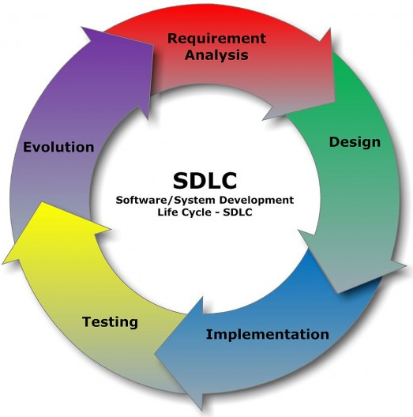

**Process Model**

**2.1 Model Description**

Online shopping is a form of electronic shopping store where the buyer is directly online to the seller’s computer usually via the internet. There are no intermediary service.The sales and purchases are completed electronically and interactively in real-time. The development of this new system contains thefollowing activities which try to develop on-line application by keeping the entire process in the view of database integration approach. User gets its Email id and password to access their account. Administrator of Shopping Cart System has multiple features such as Add, Delete, Update shopping Items.

Secure registration and profile management facilities for Customers.

* Browsing through the e-Mall to see the items that are there in each category of products like New Books and Old Books etc.
* Creating a Shopping cart so those customers can Shop N number of books and checkout finally with the entire shopping cart.
* Customers should be able to mail the Shop about the items they would like to see in the Shop.
* Secured mechanism for checking out from the Shop. Updates to customers about the Recent Items in the Shop.
* Uploading Most Purchased Items in each category of products in the Shop like New Books and Old Booksetc.

**2.2 Architecture**

A system architecture using only one single integrated model for the description of multiple views such as planning, requirement analysis, design, implementation, deployment, structure, behaviour, input data and output data views is a kind of system model.

**2.3 Development Methodology**

To remove all the disadvantages of conventional methods, a system is proposed which is an online shopping. The purpose of online shopping is to save time, save money. Through on-line shopping we can save his valuable time. One can watch and select things he wants to buy. Through online shopping we can save our money because prices are less than market prices and we receive our bought things at our home. No need to go anywhere and do shopping. We can get different varieties of things online and we can choose which one we want.

Through Online Shopping, a person who wants to buy is a many more books e-commerce web application, which retails various types of knowledgeable books. This project allows viewing various products available enables registered users to purchase desired books instantly using Cash on Delivery (Pay Later) option. This project provides an easy access to Administrators and Managers to view orders placed using Pay Later and Instant Pay options. In order to develop an e-commerce website, a numbers of Technologies must bestudied and understood.

**Requirement Analysis**

**3.1 Requirement Elicitation**

As the goal of the application is ease of use and to provide an interactive interface, extensive research has been done to gain an insight into the needs and behaviors of various users. The working of the application is made convenient and easy to use for the end user. In online web based shopping systems there are two party who interact with the system, one of them are customer who wants to buy books and other the system admin manage the system. A good web based online book shopping system should present the following factors to the customers for better usability.

* Knowing when an item has to save not save in the shopping cart.
* Returning the different parts of the site after adding an item to the shopping cart.
* Easy scanning and selecting items in the list.
* Effective categorical organization of the products.
* Simple navigation from home page to information and order links for specific products.
* Obvious shopping links or buttons.
* Consistent layout of books information.
* A well-organized web interfaces to work as admin so that he can handle all the part of the system properly.
* A customer can view the book properly but to buy he has to add the book in shopping cart, for this he has to register or have to login if he is an existing user.
* To launch the system, admin have to select the category of books, company or publish of book will remain in the system for customer view and he can select those from his panel.
* From user part or customer part when a customer orders from his part can manage the order of the product.
* A valid admin user is needed to access the information of the system for the admin.
* A valid customer ID is need to the customer to buy the product.
* Admin login to the system can view, edit, delete and update category, publisher and product related information. Also he can update the order information.

**3.1.1 Use Case Scenarios**

Web Customer actor uses some web site to make purchases online. Top level use cases are View old books and new books, Make Purchase and Client Register. View Items use case could be used by customer as top level use case if customer only wants to find and see some products. This use case could also be used as a part of Make Purchase use case. Client Register use case allows customer to register on the web site, for example to get some coupons or be invited to private sales. Note, that checkout use case is ‘included use case’ not available by itself - checkout is part of making purchase.

View book Items use case is extended by several optional use cases - customer may search for book items, browse catalog, view book items recommended for him/her, add book items to shopping cart or wish list. All these use cases are extending use cases because they provide some optional functions allowing customer to find book item.

Customer Authentication use case is included in View Recommended book Items and Add to Wish List because both require the customer to be authenticated. At the same time, item could be added to the shopping cart without user authentication.

Checkout use case includes several required uses cases. Web customer should be authenticated. It could be done through user login page, user authentication cookie ("Remember me") or Single Sign-On (SSO). Web site authentication service is used in all these use cases, while SSO also requires participation of external identity provider.

View Book Items use case is extended by several optional use cases - customer may search for items, browse catalog, view book items recommended for him/her, add book items to shopping cart or wish list. All these use cases are extending use cases because they provide some optional functions allowing customer to find item.

Customer Authentication use case is included in View Recommended Items and Add to Wish List because both require the customer to be authenticated. At the same time, book item could be added to the shopping cart without user authentication.

Checkout use case includes several required uses cases. Web customer should be authenticated. It could be done through user login page, user authentication cookie ("Remember me") or Single Sign-On (SSO). Web site authentication service is used in all these use cases, while SSO also requires participation of external identity provider.

**3.1.2 Use Case Diagrams**

Except for the Web Customer actor there are several other actors which will be described below with detailed use cases.

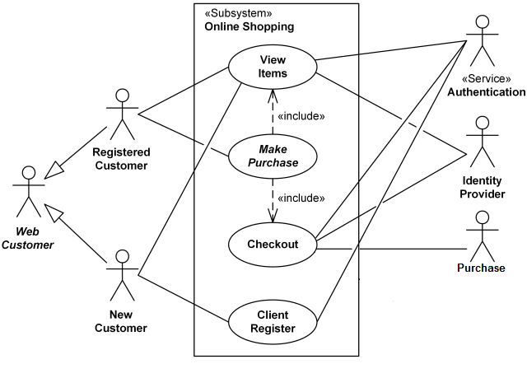

**3.2 Feasibility Study**

**3.2.1 Technical Feasibility (based on hardware & software availability)**

This involves questions such as whether the technology needed for the system exists, how difficult it will be to build, and whether the firm has enough experience using that technology. The assessment is based on outline design of system requirements in terms of input, processes, output, fields, programs and procedures. This can be qualified in terms of volume of data, trends, frequency of updating in order to give an introduction to the technical system. The application is the fact that it has been developed on windows 7 platform and a high configuration of 1GB RAM on Intel Pentium Dual core processor. This is technically feasible.The technical feasibility assessment is focused on gaining an understanding of the present technical resources of the organization and their applicability to the expected needs of the proposed system. It is an evaluation of the hardware and software and how it meets the need of the proposed system.

**3.2.2 Operational Feasibility (based on ease of understanding and use)**

Operational feasibility is the measure of how well a proposed system solves the problems, and takes advantage of the opportunities identified during scope definition and how it satisfies the requirements identified in the requirements analysis phase of system development. To ensure success, desired operational outcomes must be imparted during design and development. These include such design-dependent parameters as reliability, maintainability, supportability, usability, disposability, sustainability, affordability and others. Therefore, operational feasibility is a critical aspect of systems engineering that needs to be an integral part of the early design phases.

**3.2.3 Economical Feasibility (based on cost estimation)**

Establishing the cost-effectiveness of the proposed system i.e. if the benefits do not outweigh the costs then it is not worth going ahead. In the fast paced world today there is a great need of online social networking facilities. Thus the benefits of this project in the current scenario make it economically feasible. The purpose of the economic feasibility assessment is to determine the positive economic benefits to the organization that the proposed system will provide. It includes quantification and identification of all the benefits expected. This assessment typically involves a cost/benefits analysis.

**3.3 Requirement Analysis of the Proposed System**

**3.3.1 Context Level DFD**

A data flow diagram (DFD) is a graphical representation of the "flow" of data through an information system, modeling its process aspects. A DFD is often used as a preliminary step to create an overview of the system, which can later be elaborated.

Cart

Management

Order

Management

Book

Management

System User Management

Login Management

**3.3.2 Level-1 DFDs**

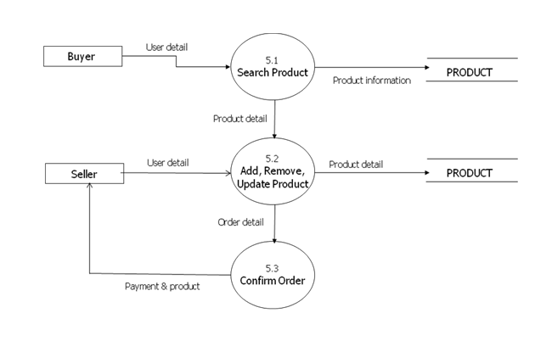

**3.3.3 Level-2 DFDs**

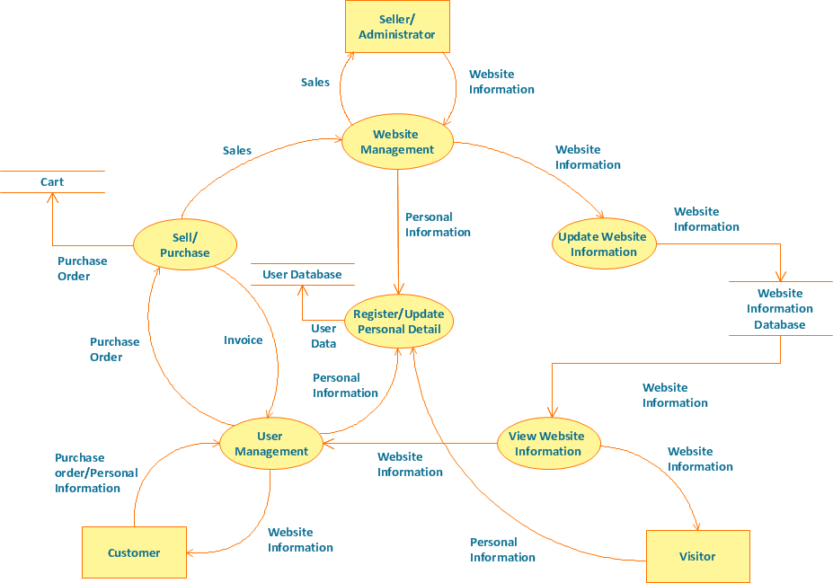

**3.3.4 Data Dictionary**

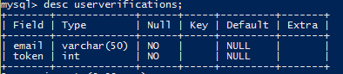

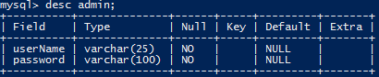

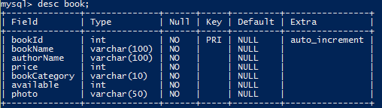

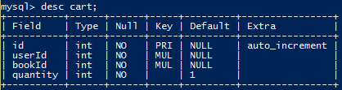

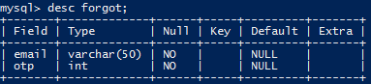

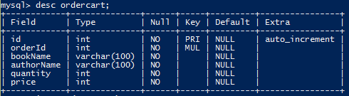

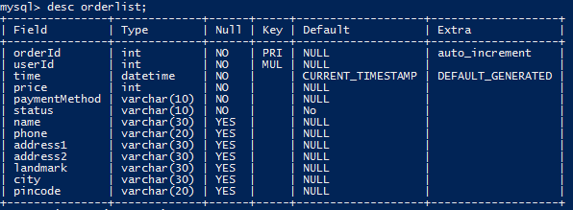

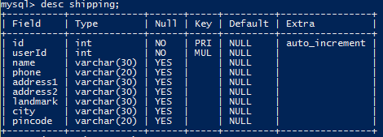

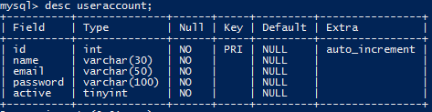

**3.3.5 E-R Diagrams**

Admin

`

1

1

N

N

N

N

1

1

1

1

1

1

M

M

M

M

M

M

Buy

See

Verify

Change

Password

Gives

Added

To

Manage

See

Has

Book

Order List

Forgot

User Verification

Shipping

Order Cart

Cart

User Account

**3.4 Software Requirement Specifications (SRS)**

1. Operating System : Windows 7 and upwards operating system
2. Server : Apache Tomcat (Localhost)
3. Language : Java 11
4. Database : MySQL 8.0.19
5. IDE : NetBeans 12.0
6. Browser : Chrome, Edge, Firefox

**3.5 Hardware and Other Requirements**

1. Processor : Dual core Intel
2. Clock Speed : 1.8 GHz
3. Storage : 750 MB free disk space
4. RAM : 2GB or more
5. Keyboard : 101 Keys
6. Mouse : Optical Mouse

**4. System Design**

**4.1 Design Approach – Top Down/ Bottom Up (Whichever applicable)**

In the top-down approach, a complex algorithm is broken down into smaller fragments, better known as ‘modules.’ These modules are then further broken down into smaller fragments until they can no longer be fragmented. However, during the modularization process, you must always maintain the integrity and originality of the algorithm.By breaking a bigger problem into smaller fragments, the top-down approach minimizes the complications usually incurred while designing algorithms. Furthermore, in this approach, each function in a code is unique and works independently of other functions. The top-down approach is heavily used in the java programming language.

Contrary to the top-down approach, the bottom-up approach focuses on designing an algorithm by beginning at the very basic level and building up as it goes. In this approach, the modules are designed individually and are then integrated together to form a complete algorithmic design.

So, in this method, each and every module is built and tested at an individual level prior to integrating them to build a concrete solution. The unit testing is performed by leveraging specific low-level functions.

**4.2 Design Methodology – Function Oriented/ Object Oriented**

System design is the solution for the creation of a new system. This phase focuses on the detailed implementation of the feasible system. It emphasis on translating design. Specifications to performance specification. System design has two phases of development

* Logical design
* Physical design

During logical design phase the analyst describes inputs (sources), output s(destinations), databases (data sores) and procedures (data flows) all in a format that meets the user requirements. The analyst also specifies the needs of the user at a level that virtually determines the information flow in and out of the system and the data resources. Here the logical design is done through data flow diagrams and database design. The physical design is followed by physical design or coding. Physical design produces the working system by defining the design specifications, which specify exactly what the candidate system must do. The programmers write the necessary programs that accept input from the user, perform necessary processing on accepted data and produce the required report on a hard copy or display it on the screen.

**4.3 Module and Sub-Module Description**

* **Master Maintenance:** This module consists of information about the products and services. This includes two sub-modules, Product master and Price master.
* **Product master** includes the information about particular product, such as product number, item, name, and category, images of products, description, features, and constraints of products. All these will be entered to the database through product master and hence made available in the website. In Other words product master is the admin area for the vendors/sellers where they can put information about their products which are to be displayed in the website.
* **Price master** deals with the cost of the product, discounts applicable for the particular product of a vendor/seller.
* **Transactions:**Payment will be done on Delivery of the items (Cash on Delivery).
* **Reporting:**In this module all reports will be generated. Whenever an item is sold, or customer orders a product, its vendor should be sent an alert via email immediately so that he can ship that item soon.

This module has 3 sub modules; Stock Reports, Order Reports and Delivery Reports.

* **Stock Report** will produce reports of the quantity of the products available and product status.
* **Order Report** will have the list of products ordered and the customer details who have bought that product, which are undelivered.
* **Delivery Reports** will generate products list, which are delivered to customers.
* **House Keeping:** This module takes care of data which are older than a certain period. It will allow the vendor to archive the reports generated or transaction and business history reported by Reporting module.

**4.4 User Interface Design - Snapshots**

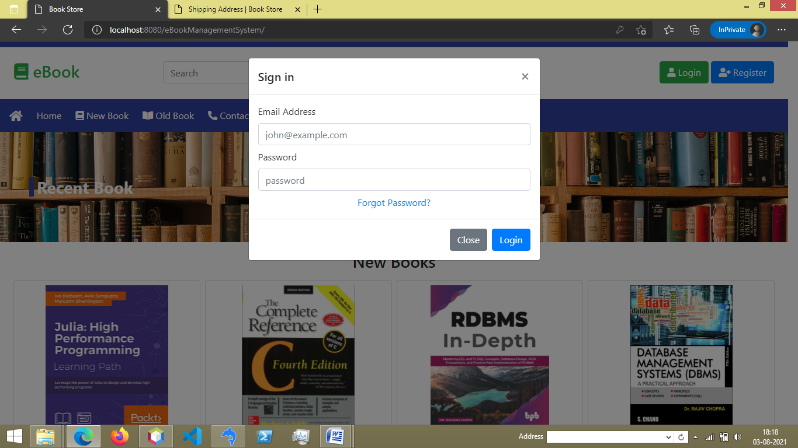

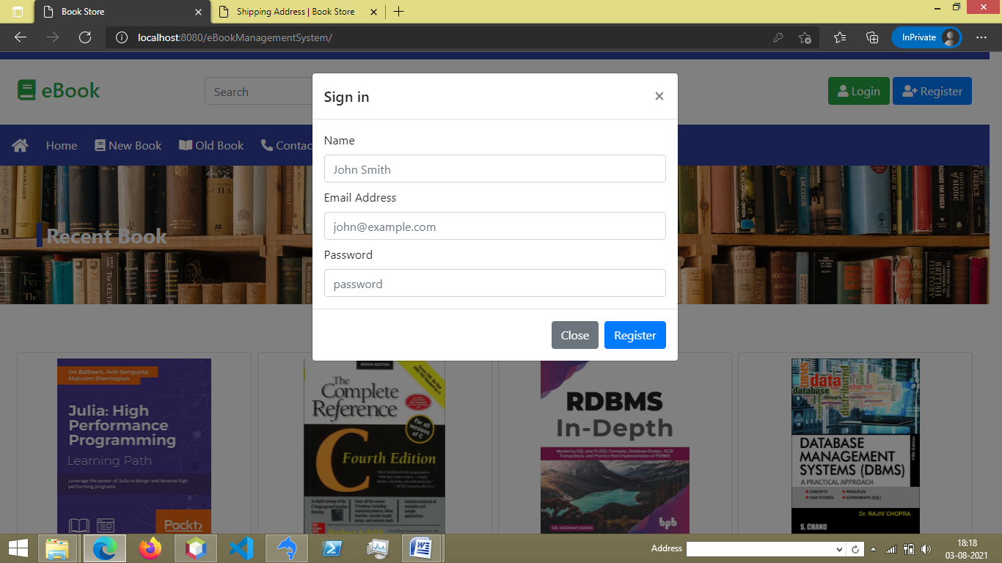

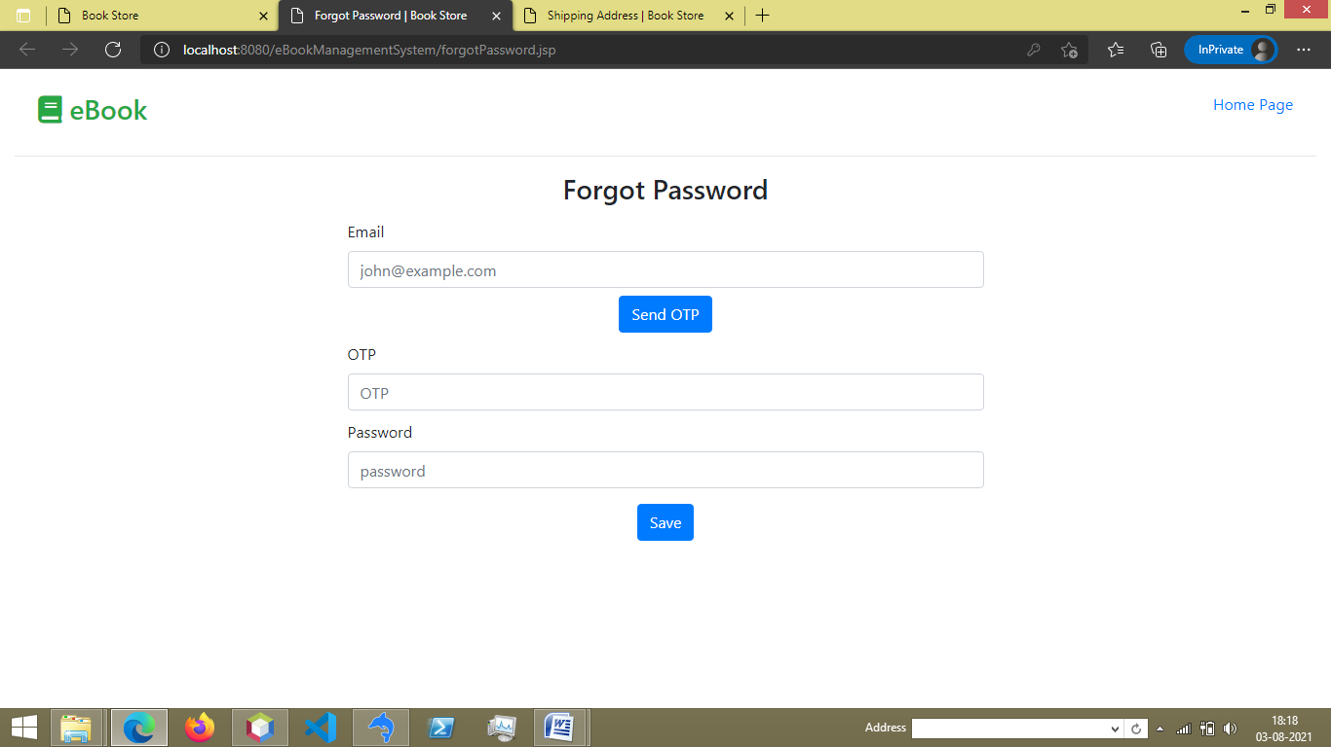

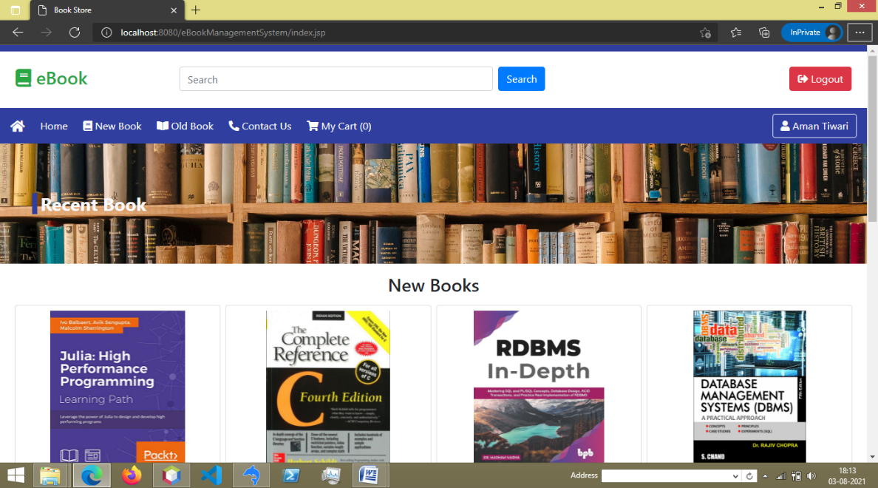

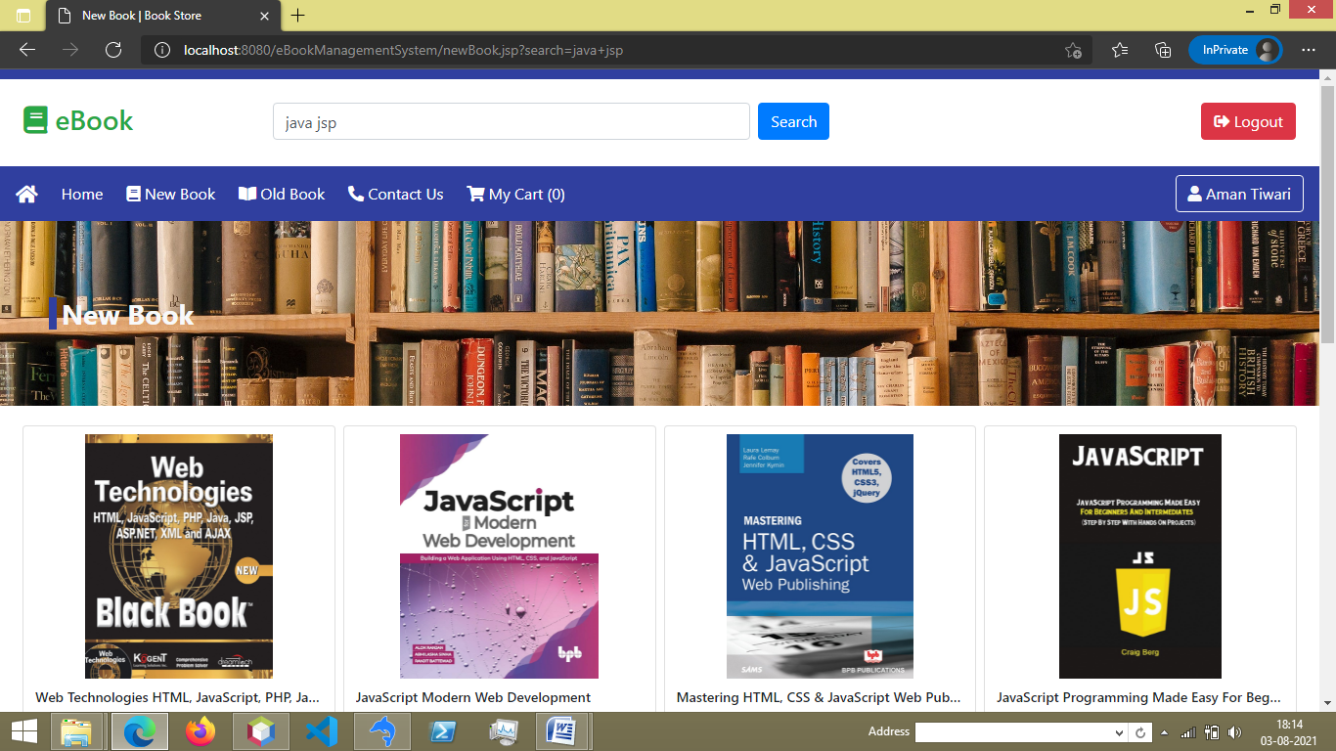

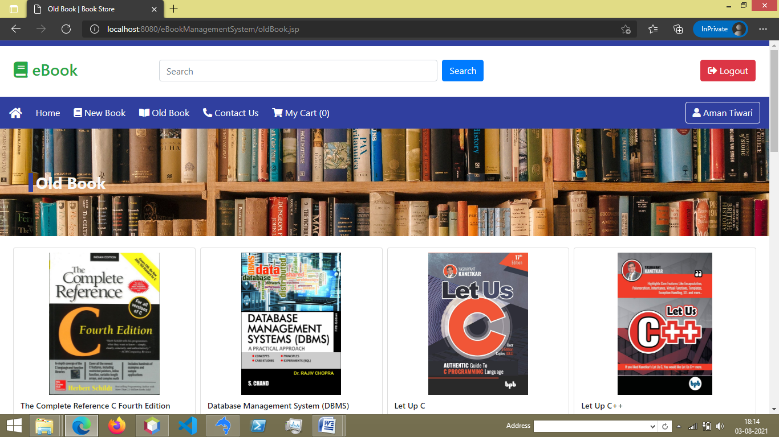

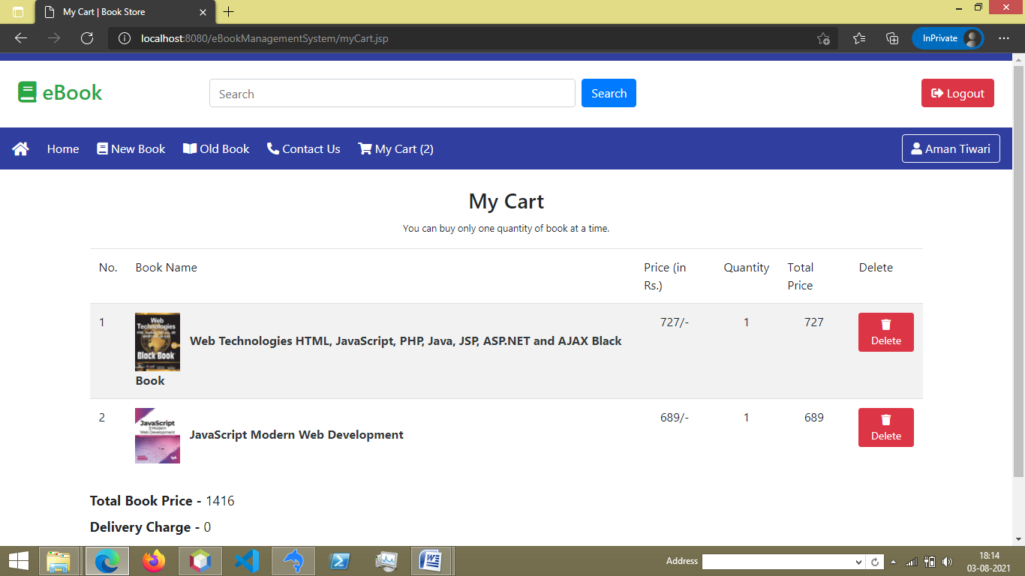

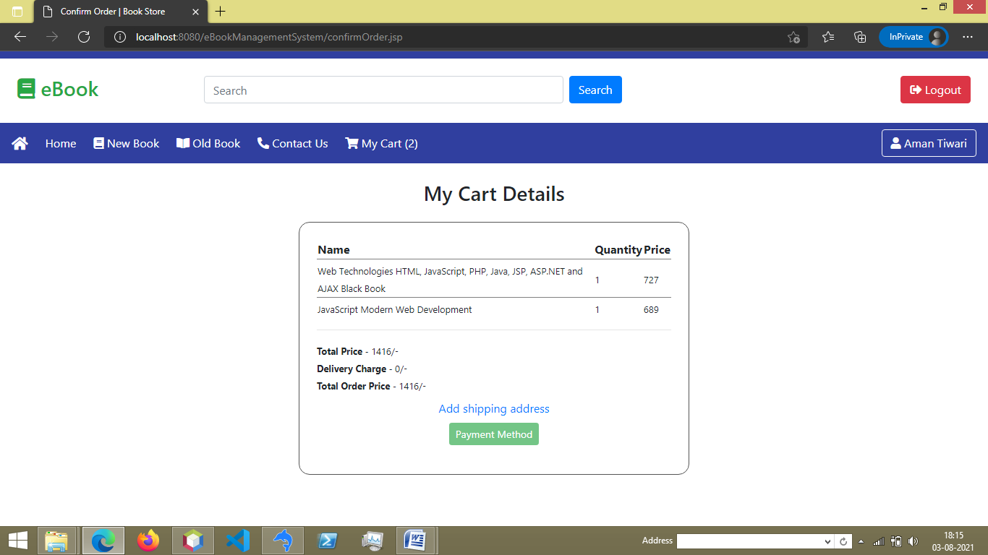

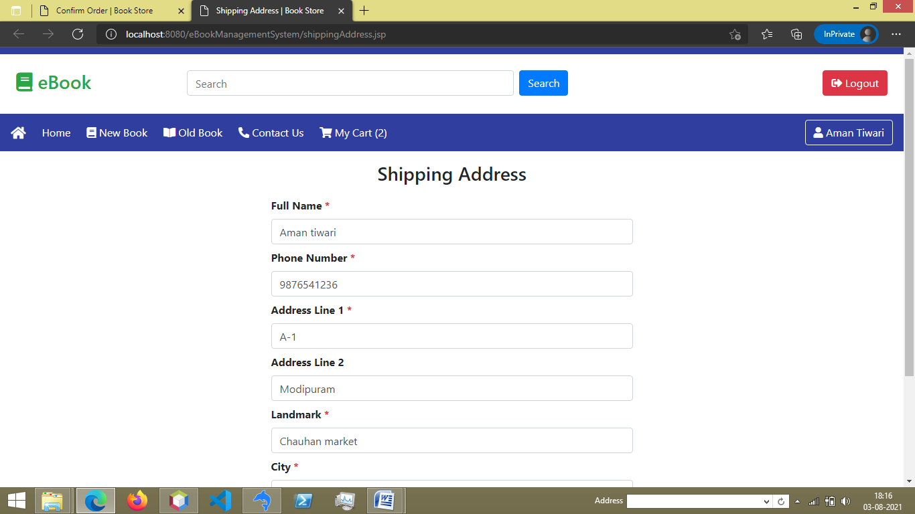

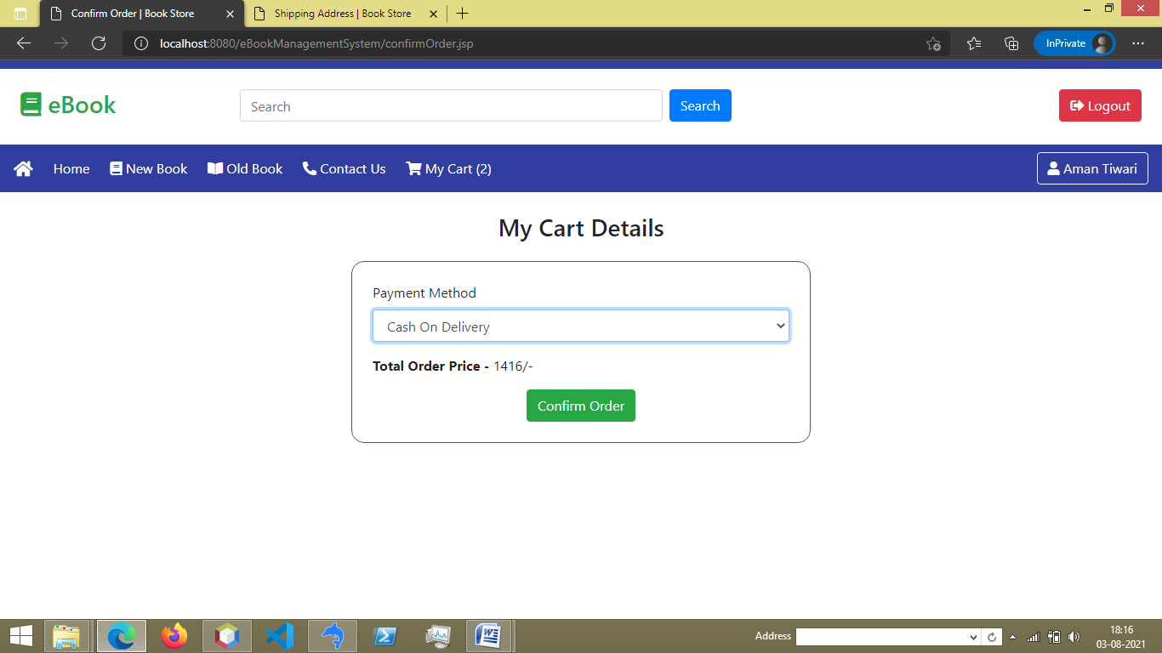

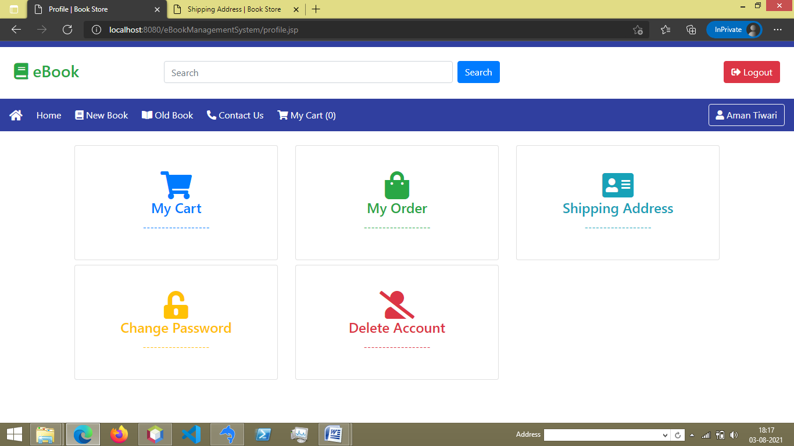

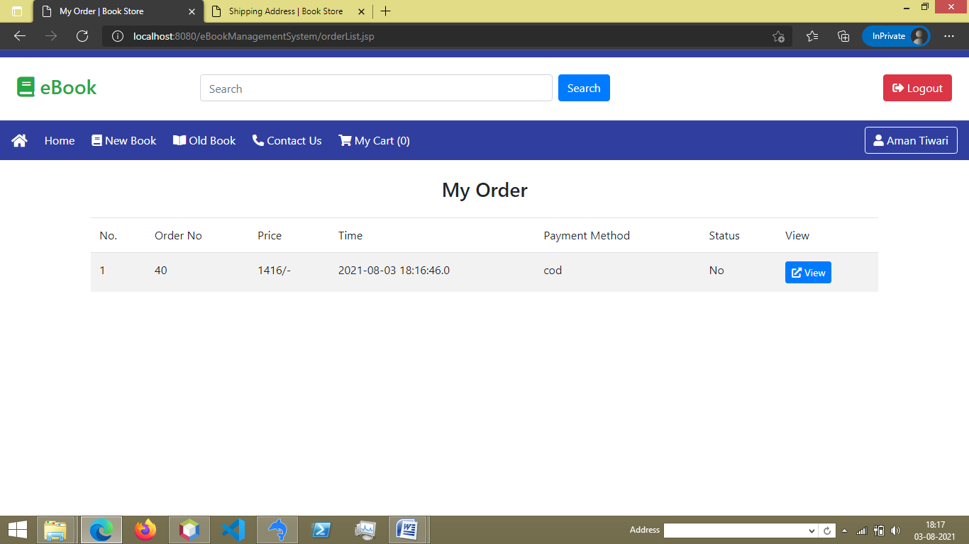

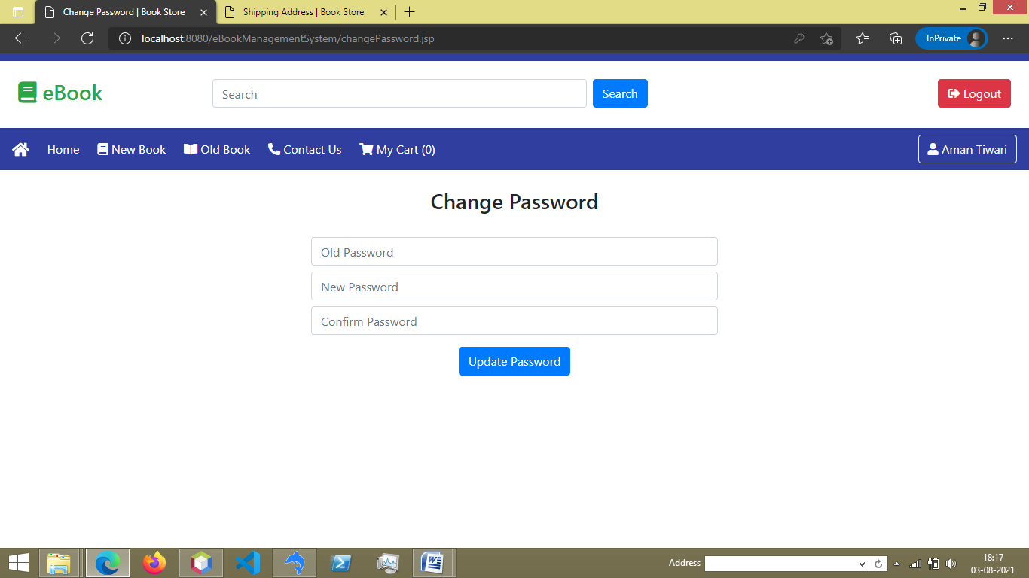

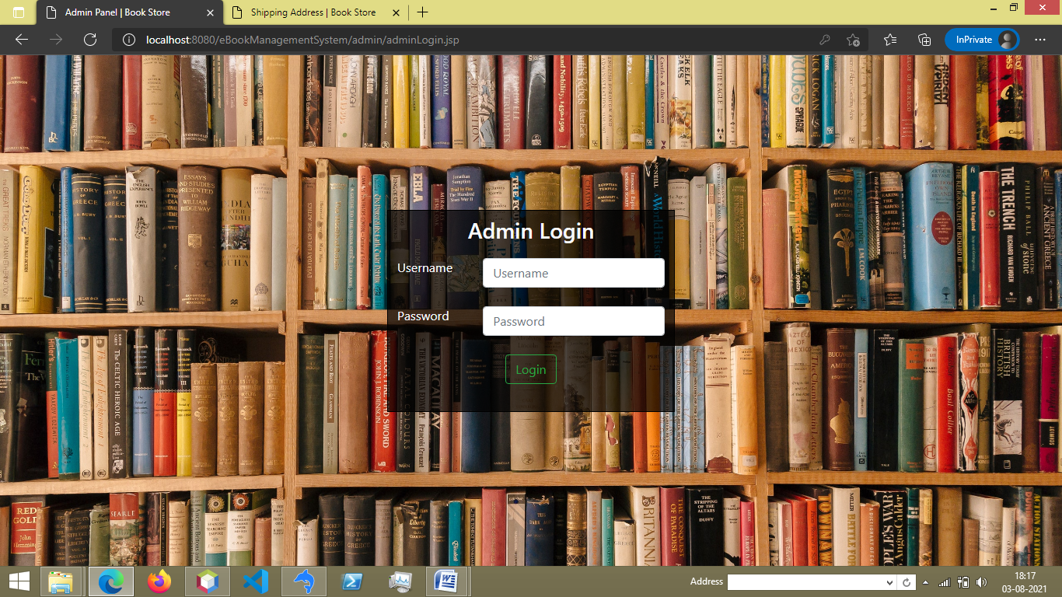

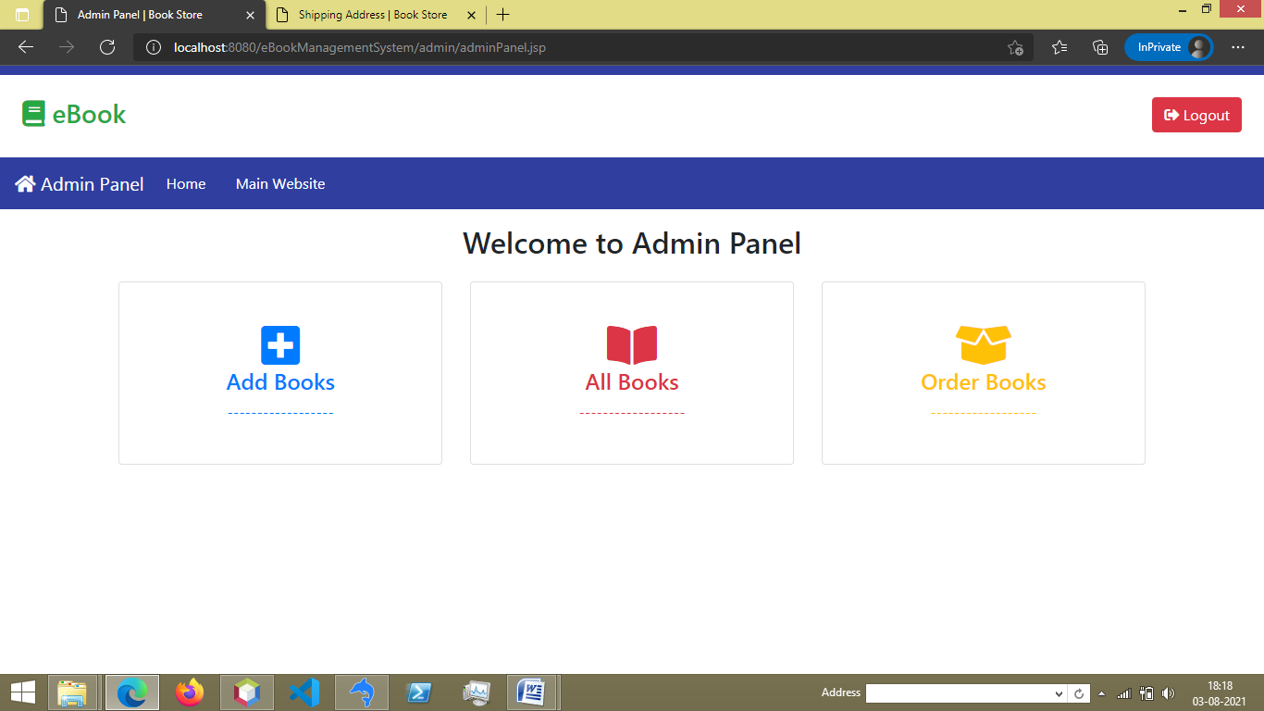

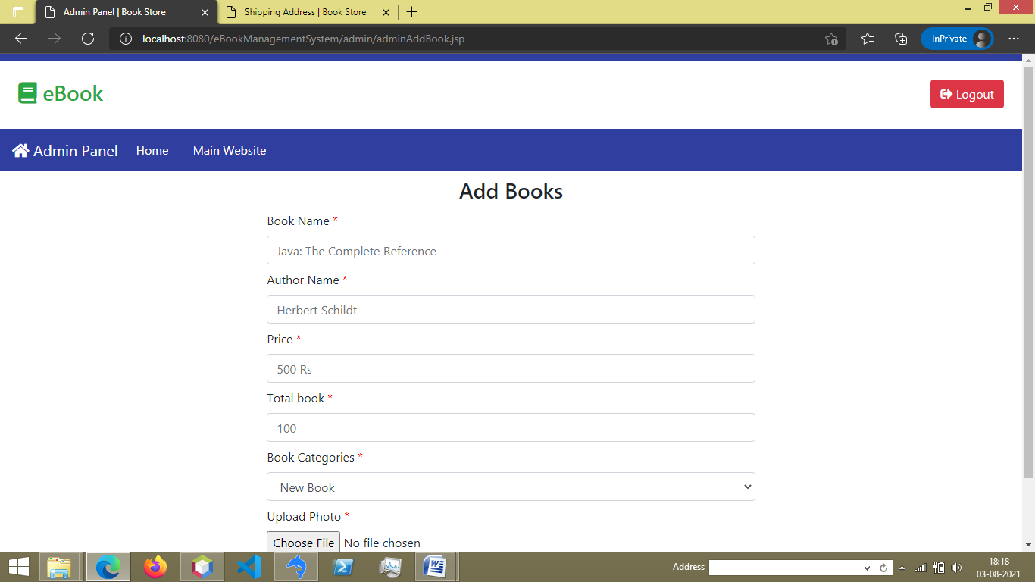

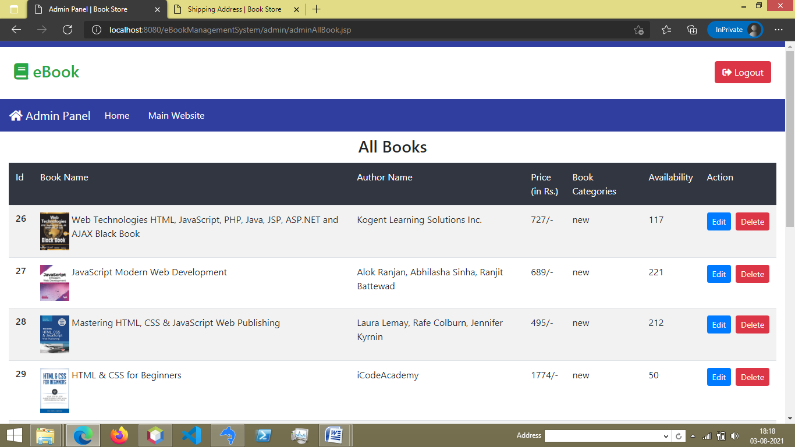

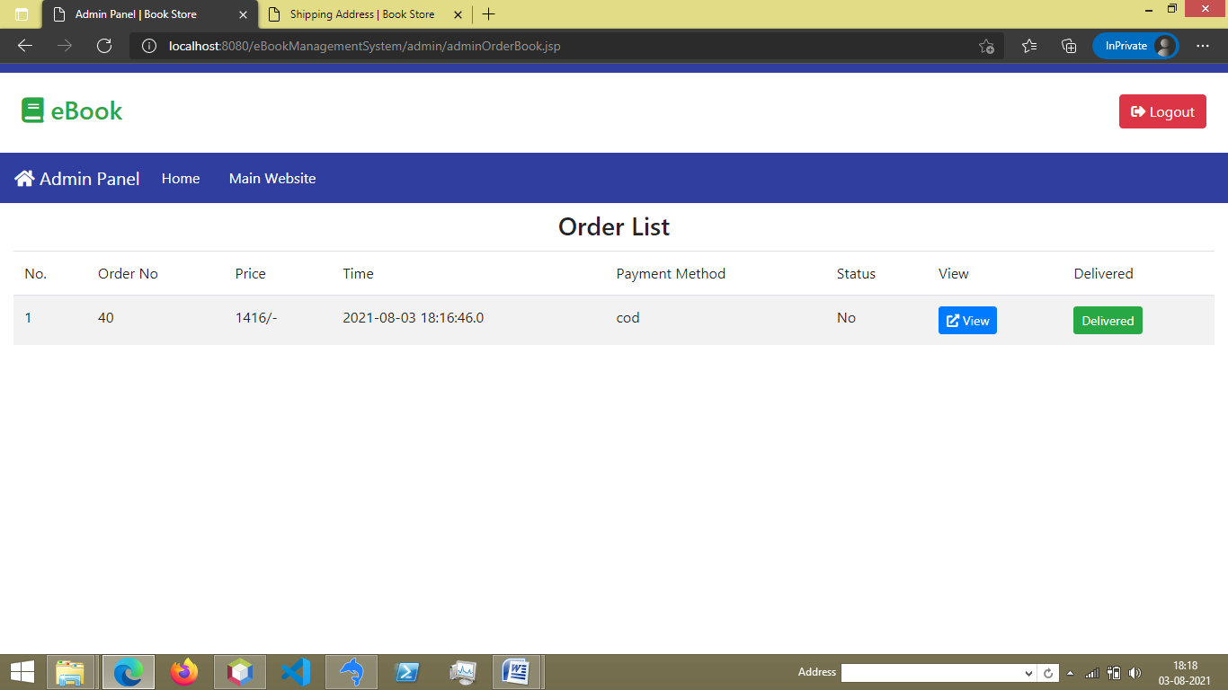

**5. Coding**

**5.1 Hard Code**

**index.jsp**

<%--

Document : index

Created on : 31-May-2021, 9:09:14 PM

Author : chetan

--%>

<%@page import="java.util.ArrayList"%>

<%@page import="com.database.DBConnect"%>

<%@page import="java.util.List"%>

<%@page import="com.detail.BookDetail"%>

<%@page import="com.dao.UserBookDAO"%>

<%

UserBookDAO dao1 = new UserBookDAO(DBConnect.getConnection());

List<BookDetail> list1;

List<BookDetail> list2;

list1 = dao1.newBook();

list2 = dao1.oldBook();

%>

<%@page contentType="text/html" pageEncoding="UTF-8"%>

<!DOCTYPE html>

<html>

<head>

<%@include file="./component/header.jsp" %>

<title>Book Store</title>

</head>

<body>

<%@include file="./component/navbar.jsp" %>

<div class="container-fluid cover-img">

<div class="row">

<div class="col-12">

<h3 class="text-light mt-2 mb-2 cover-img-text">Recent Book</h3>

</div>

</div>

</div>

<div class="card-show container-fluid mt-3 mb-4">

<div class="row m-1">

<div class="col-12 text-center">

<h3>New Books</h3>

</div>

</div>

<div class="row mr-1 ml-1">

<%

for(BookDetail bd : list1) {

%>

<div class="col-xl-3 col-lg-3 col-md-4 col-sm-6 col-6 m-0 p-1">

<div class="card card-highlight m-0 p-0">

<div class="p-2 text-center">

<img src="./img/books-img/<%= bd.getPhoto() %>" class="img-fluid card-img-show">

</div>

<div class="card-body m-0 pt-0 pl-1 pr-1 pb-2 ">

<div style="font-weight: 600; font-size: 14px; white-space: nowrap; text-overflow: ellipsis; overflow: hidden; " class="ml-2 mr-2" >

<%= bd.getBookName() %>

</div>

<div class="ml-2 mr-2">

MRP - <span><%= bd.getPrice() %></span>/- Rs

</div>

<div style="display: flex;">

<a href="./viewBook.jsp?bookId=<%= bd.getId() %>" target="_blank" class="btn btn-outline-primary form-control ml-2 mr-1 btn-sm">View Item</a>

<button onclick="addCart(<%= bd.getId() %>)" class="btn btn-outline-dark btn-sm mr-2">

<i class="fas fa-cart-plus"></i>

</button>

</div>

</div>

</div>

</div>

<%

}

%>

</div>

<div class="row m-1">

<div class="col-12 text-center">

<h3>Old Books</h3>

</div>

</div>

<div class="row mr-1 ml-1">

<%

for(BookDetail bd : list2) {

%>

<div class="col-xl-3 col-lg-3 col-md-4 col-sm-6 col-6 m-0 p-1">

<div class="card card-highlight m-0 p-0">

<div class="p-2 text-center">

<img src="./img/books-img/<%= bd.getPhoto() %>" class="img-fluid card-img-show">

</div>

<div class="card-body m-0 pt-0 pl-1 pr-1 pb-2 ">

<div style="font-weight: 600; font-size: 14px; white-space: nowrap; text-overflow: ellipsis; overflow: hidden; " class="ml-2 mr-2" >

<%= bd.getBookName() %>

</div>

<div class="ml-2 mr-2">

MRP - <span><%= bd.getPrice() %></span>/- Rs

</div>

<div style="display: flex;">

<a href="./viewBook.jsp?bookId=<%= bd.getId() %>" target="_blank" class="btn btn-outline-primary form-control ml-2 mr-1 btn-sm">View Item</a>

<button onclick="addCart(<%= bd.getId() %>)" class="btn btn-outline-dark btn-sm mr-2">

<i class="fas fa-cart-plus"></i>

</button>

</div>

</div>

</div>

</div>

<%

}

%>

</div>

</div>

<script>

$("#searchBook").attr("action","./newBook.jsp");

$("#searchBook2").attr("action","./newBook.jsp");

</script>

<script src="js/addCart.js" type="text/javascript"></script>

</body>

</html>

**newBook.jsp**

<%--

Document : index

Created on : 31-May-2021, 9:09:14 PM

Author : chetan

--%>

<%@page import="com.dao.SearchDAO"%>

<%@page import="com.database.DBConnect"%>

<%@page import="java.util.List"%>

<%@page import="com.detail.BookDetail"%>

<%@page import="com.dao.UserBookDAO"%>

<%

String search = null;

try{

search = request.getParameter("search");

} catch(Exception e) {}

if(search==null){

search = "";

}

SearchDAO dao2 = new SearchDAO(DBConnect.getConnection());

UserBookDAO dao1 = new UserBookDAO(DBConnect.getConnection());

int pageNo = 1;

try{

pageNo = Integer.parseInt(request.getParameter("pageNo"));

} catch(Exception e){}

List<BookDetail> list1;

int totalPage = 1;

if(search.trim().equals("")) {

list1 = dao1.newBookByPageNo(pageNo);

totalPage = dao1.countNewBook();

} else {

StringBuilder query = new StringBuilder("FROM book WHERE bookCategory = 'new' and ( bookName LIKE '%"+search+"%'");

String[] search2 = search.split(" ");

for (String search21 : search2) {

if (!search21.trim().equals("")) {

query.append(" OR bookName LIKE '%").append(search21).append("%'");

}

}

query.append(") ");

list1 = dao2.newBookSearch(new String("SELECT * "+query), pageNo);

totalPage = dao2.newBookSearchPageCount(new String("SELECT COUNT(*) AS total "+query));

}

%>

<%@page contentType="text/html" pageEncoding="UTF-8"%>

<!DOCTYPE html>

<html>

<head>

<%@include file="./component/header.jsp" %>

<title>New Book | Book Store</title>

</head>

<body>

<%@include file="./component/navbar.jsp" %>

<div class="container-fluid cover-img">

<div class="row">

<div class="col-12">

<h3 class="text-light mt-2 mb-2 cover-img-text">New Book</h3>

</div>

</div>

</div>

<div class="card-show container-fluid mt-3 mb-4">

<div class="row mr-1 ml-1">

<%

for(BookDetail bd : list1) {

%>

<div class="col-xl-3 col-lg-3 col-md-4 col-sm-6 col-6 m-0 p-1">

<div class="card card-highlight m-0 p-0">

<div class="p-2 text-center">

<img src="./img/books-img/<%= bd.getPhoto() %>" class="img-fluid card-img-show">

</div>

<div class="card-body m-0 pt-0 pl-1 pr-1 pb-2 ">

<div style="font-weight: 600; font-size: 14px; white-space: nowrap; text-overflow: ellipsis; overflow: hidden; " class="ml-2 mr-2" >

<%= bd.getBookName() %>

</div>

<div class="ml-2 mr-2">

MRP - <span><%= bd.getPrice() %></span>/- Rs

</div>

<div style="display: flex;">

<a href="./viewBook.jsp?bookId=<%= bd.getId() %>" target="_blank" class="btn btn-outline-primary form-control ml-2 mr-1 btn-sm">View Item</a>

<button onclick="addCart(<%= bd.getId() %>)" class="btn btn-outline-dark btn-sm mr-2">

<i class="fas fa-cart-plus"></i>

</button>

</div>

</div>

</div>

</div>

<%

}

if (list1.size()==0){

%>

<div class="col-12 text-danger text-center">

<h1><i class="far fa-frown"></i></h1>

<h1>No result found</h1>

</div>

<%

}

%>

</div>

<div class="row mt-2 mb-1">

<%

if (list1.size()!=0){

%>

<div class="col-12 text-center">

Page

</div>

<%

}

%>

<div class="col-12 text-center">

<nav>

<ul class="pagination pagination-sm justify-content-center">

<%

int pageN = 0;

while(totalPage>0) {

pageN+=1;

if(pageN==pageNo){

%>

<li class="page-item active">

<span class="page-link" ><%= pageN %></span>

</li>

<%

} else {

%>

<li class="page-item">

<a class="page-link" href="./newBook.jsp?search=<%= search %>&pageNo=<%= pageN %>" >

<%= pageN %>

</a>

</li>

<%

}

totalPage-=20;

}

%>

</ul>

</nav>

</div>

</div>

</div>

<script>

$("#searchInput").val("<%= search %>");

$("#searchInput2").val("<%= search %>");

$("#searchBook").attr("action","./newBook.jsp");

$("#searchBook2").attr("action","./newBook.jsp");

</script>

<script src="js/addCart.js" type="text/javascript"></script>

</body>

</html>

**oldBook.jsp**

<%--

Document : index

Created on : 31-May-2021, 9:09:14 PM

Author : chetan

--%>

<%@page import="com.dao.SearchDAO"%>

<%@page import="com.database.DBConnect"%>

<%@page import="java.util.List"%>

<%@page import="com.detail.BookDetail"%>

<%@page import="com.dao.UserBookDAO"%>

<%

String search = null;

try{

search = request.getParameter("search");

} catch(Exception e) {}

if(search==null){

search = "";

}

UserBookDAO dao1 = new UserBookDAO(DBConnect.getConnection());

SearchDAO dao2 = new SearchDAO(DBConnect.getConnection());

int pageNo = 1;

try{

pageNo = Integer.parseInt(request.getParameter("pageNo"));

} catch(Exception e){}

List<BookDetail> list1;

int totalPage = 1;

if(search.trim().equals("")) {

list1 = dao1.oldBookByPageNo(pageNo);

totalPage = dao1.countOldBook();

} else {

StringBuilder query = new StringBuilder("FROM book WHERE bookCategory = 'old' and ( bookName LIKE '%"+search+"%'");

String[] search2 = search.split(" ");

for (String search21 : search2) {

if (!search21.trim().equals("")) {

query.append(" OR bookName LIKE '%").append(search21).append("%'");

}

}

query.append(") ");

list1 = dao2.newBookSearch(new String("SELECT * "+query), pageNo);

totalPage = dao2.newBookSearchPageCount(new String("SELECT COUNT(*) AS total "+query));

}

%>

<%@page contentType="text/html" pageEncoding="UTF-8"%>

<!DOCTYPE html>

<html>

<head>

<%@include file="./component/header.jsp" %>

<title>Old Book | Book Store</title>

</head>

<body>

<%@include file="./component/navbar.jsp" %>

<div class="container-fluid cover-img">

<div class="row">

<div class="col-12">

<h3 class="text-light mt-2 mb-2 cover-img-text">Old Book</h3>

</div>

</div>

</div>

<div class="card-show container-fluid mt-3 mb-4">

<div class="row mr-1 ml-1">

<%

for(BookDetail bd : list1) {

%>

<div class="col-xl-3 col-lg-3 col-md-4 col-sm-6 col-6 m-0 p-1">

<div class="card card-highlight m-0 p-0">

<div class="p-2 text-center">

<img src="./img/books-img/<%= bd.getPhoto() %>" class="img-fluid card-img-show">

</div>

<div class="card-body m-0 pt-0 pl-1 pr-1 pb-2 ">

<div style="font-weight: 600; font-size: 14px; white-space: nowrap; text-overflow: ellipsis; overflow: hidden; " class="ml-2 mr-2" >

<%= bd.getBookName() %>

</div>

<div class="ml-2 mr-2">

MRP - <span><%= bd.getPrice() %></span>/- Rs

</div>

<div style="display: flex;">

<a href="./viewBook.jsp?bookId=<%= bd.getId() %>" target="_blank" class="btn btn-outline-primary form-control ml-2 mr-1 btn-sm">View Item</a>

<button onclick="addCart(<%= bd.getId() %>)" class="btn btn-outline-dark btn-sm mr-2">

<i class="fas fa-cart-plus"></i>

</button>

</div>

</div>

</div>

</div>

<%

}

if (list1.size()==0){

%>

<div class="col-12 text-danger text-center">

<h1><i class="far fa-frown"></i></h1>

<h1>No result found</h1>

</div>

<%

}

%>

</div>

<div class="row mt-2 mb-1">

<%

if (list1.size()!=0){

%>

<div class="col-12 text-center">

Page

</div>

<%

}

%>

<div class="col-12 text-center">

<nav>

<ul class="pagination pagination-sm justify-content-center">

<%

int pageN = 0;

while(totalPage>0) {

pageN+=1;

if(pageN==pageNo){

%>

<li class="page-item active">

<span class="page-link" ><%= pageN %></span>

</li>

<%

} else {

%>

<li class="page-item">

<a class="page-link" href="./oldBook.jsp?search=<%= search %>&pageNo=<%= pageN %>" >

<%= pageN %>

</a>

</li>

<%

}

totalPage-=20;

}

%>

</ul>

</nav>

</div>

</div>

</div>

<script>

$("#searchInput").val("<%= search %>");

$("#searchInput2").val("<%= search %>");

$("#searchBook").attr("action","./oldBook.jsp");

$("#searchBook2").attr("action","./oldBook.jsp");

</script>

<script src="js/addCart.js" type="text/javascript"></script>

</body>

</html>

**profile.jsp**

<%--

Document : profile

Created on : 11-Jun-2021, 12:31:58 PM

Author : chetan

--%>

<%

if(session.getAttribute("userL")==null){

response.sendRedirect("./index.jsp");

} else {

%>

<%@page contentType="text/html" pageEncoding="UTF-8"%>

<!DOCTYPE html>

<html>

<head>

<%@include file="./component/header.jsp" %>

<title>Profile | Book Store</title>

<style>

.card-link-a:hover{

text-decoration: none;

}

.card-custom{

background: white;

text-decoration: none;

}

.card-custom:hover{

background-color: #ebe4e4;

text-decoration: none;

}

</style>

</head>

<body>

<%@include file="./component/navbar.jsp" %>

<div class="container-md mt-3 mb-5">

<div class="row">

<div class="col-xl-4 col-lg-4 col-md-6 col-sm-6 col-12 mt-2">

<a class="card-link-a" href="./myCart.jsp">

<div class="card text-center text-primary p-4 card-custom">

<div class="card-body">

<i class="fas fa-shopping-cart fa-3x"></i>

<h4>My Cart</h4>

------------------

</div>

</div>

</a>

</div>

<div class="col-xl-4 col-lg-4 col-md-6 col-sm-6 col-12 mt-2">

<a class="card-link-a" href="./orderList.jsp">

<div class="card text-center text-success p-4 card-custom">

<div class="card-body">

<i class="fas fa-shopping-bag fa-3x"></i>

<h4>My Order</h4>

------------------

</div>

</div>

</a>

</div>

<div class="col-xl-4 col-lg-4 col-md-6 col-sm-6 col-12 mt-2">

<a class="card-link-a" href="./shippingAddress.jsp">

<div class="card text-center text-info p-4 card-custom">

<div class="card-body">

<i class="fas fa-address-card fa-3x"></i>

<h4>Shipping Address</h4>

------------------

</div>

</div>

</a>

</div>

<div class="col-xl-4 col-lg-4 col-md-6 col-sm-6 col-12 mt-2">

<a class="card-link-a" href="./changePassword.jsp">

<div class="card text-center text-warning p-4 card-custom">

<div class="card-body">

<i class="fas fa-unlock-alt fa-3x"></i>

<h4>Change Password</h4>

------------------

</div>

</div>

</a>

</div>

<div class="col-xl-4 col-lg-4 col-md-6 col-sm-6 col-12 mt-2">

<a class="card-link-a" onclick="deleteAccount()" >

<div class="card text-center text-danger p-4 card-custom">

<div class="card-body">

<i class="fas fa-user-slash fa-3x"></i>

<h4>Delete Account</h4>

------------------

</div>

</div>

</a>

</div>

</div>

</div>

<script>

$("#searchBook").attr("action","./newBook.jsp");

$("#searchBook2").attr("action","./newBook.jsp");

</script>

<script src="js/deleteAccount.js" type="text/javascript"></script>

</body>

</html>

<%

}

%>

**adminPanel.jsp**

<%--

Document : adminPanel

Created on : 06-Jun-2021, 10:33:07 AM

Author : chetan

--%>

<%

if(session.getAttribute("admin")==null){

response.sendRedirect("./adminLogin.jsp");

} else {

%>

<%@page contentType="text/html" pageEncoding="UTF-8"%>

<!DOCTYPE html>

<html>

<head>

<%@include file="adminHead.jsp" %>

<title>Admin Panel | Book Store</title>

</head>

<body>

<%@include file="adminNavbar.jsp" %>

<div class="container mt-3 mb-5">

<div class="row">

<div class="col-12 text-center mb-2">

<h2>Welcome to Admin Panel</h2>

</div>

</div>

<div class="row">

<div class="col-xl-4 col-lg-4 col-md-6 col-sm-12 col-12 mt-2">

<a class="card-link-a" href="./adminAddBook.jsp">

<div class="card text-center text-primary p-4 card-custom">

<div class="card-body">

<i class="fas fa-plus-square fa-3x"></i>

<h4>Add Books</h4>

------------------

</div>

</div>

</a>

</div>

<div class="col-xl-4 col-lg-4 col-md-6 col-sm-12 col-12 mt-2">

<a class="card-link-a" href="./adminAllBook.jsp">

<div class="card text-center text-danger p-4 card-custom">

<div class="card-body">

<i class="fas fa-book-open fa-3x"></i>

<h4>All Books</h4>

------------------

</div>

</div>

</a>

</div>

<div class="col-xl-4 col-lg-4 col-md-6 col-sm-12 col-12 mt-2">

<a class="card-link-a" href="./adminOrderBook.jsp">

<div class="card text-center text-warning p-4 card-custom">

<div class="card-body">

<i class="fas fa-box-open fa-3x"></i>

<h4>Order Books</h4>

------------------

</div>

</div>

</a>

</div>

</div>

</div>

</body>

</html>

<%

}

%>

**6. Testing**

**6.1 Methodology of Testing used in the project**

The software units in a system are modules and routines that are assembled and integrated to perform a specific function. Unit testing focuses first on modules, independently of one another, to locate errors. This enables us to detect errors in coding and logic that are contained within each module. This testing includes entering data and ascertaining if the value matches to the type and size supported by JSP. The various controls are tested to ensure that each performs its actions as required.

**6.2 Test Cases**

A test case is a tool used in the process. Test cases may be prepared for software verification and software validation to determine if the product was built according to the requirements of the user. Other methods, such as reviews, may be used early in the life cycle to provide for software validation.

**Black-Box Testing**

Black-box testing is a method of software testing that examines the functionality of an application without peering into its internal structures or workings. This method of test can be applied virtually to every level of software testing: unit, integration, system and acceptance. It typically comprises most if not all higher level testing, but can also dominate unit testing as well.

**White-Box Testing**

White-box testing (also known as clear box testing, glass box testing, transparent box testing, and structural testing) is a method of testing software that tests internal structures or workings of an application, as opposed to its functionality (i.e. black-box testing). In white-box testing an internal perspective of the system, as well as programming skills, are used to design test cases. The tester chooses inputs to exercise paths through the code and determine the appropriate outputs. This is analogous to testing nodes in a circuit, e.g. in-circuit testing (ICT). White-box testing can be applied at the unit, integration and system levels of the software testing process. Although traditional testers tended to think of white-box testing as being done at the unit level, it is used for integration and system testing more frequently today. It can test paths within a unit, paths between units during integration, and between subsystems during a system–level test. Though this method of test design can uncover many errors or problems, it has the potential to miss unimplemented parts of the specification or missing requirements.

**6.3 Steps of Testing of Module**

* For Module Testing, designing a Test Case is an important segment. While designing test cases for a module test, a tester has to take two things into consideration.
  + Specification for the module
  + The module's source code
* Analyze the module's logic by using one or more of the white box methods, and then supplement these test cases by applying black box methods to the modules specification.
* Once the test case is designed, the next step is to combine the module for testing. For this, the method used is either an **Incremental or non-Incremental method**.
* Non-incremental method- all modules are tested independently. First, it combines all modules and then tests the whole program.
* Incremental method- each module is tested first and then gradually incremented to the tested collection. It does a step wise retesting
* Incremental Testing, there are two approaches – Top down and Bottom Up testing
* To execute the module with the selected data, it requires a **driver**for supplying the test data, monitoring the execution and capturing the results

**7. Implementation/Maintenance**

**7.1 Installation Procedure**

### Step 1 - Download JDK

Open the browser and search for Download JDK 11 or click the [link](https://www.oracle.com/java/technologies/javase-jdk11-downloads.html) to download from Oracle website.

Accept the License Agreement and click on the link to download the installer as highlighted in Fig 7.1.1. It will start downloading JDK 11 installer for Windows.

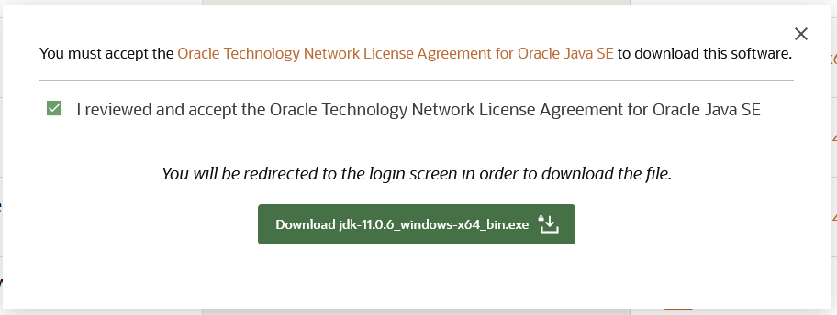

Fig 7.1.1

### Step 2 - Install JDK

Now execute the downloaded JDK installer by double-clicking it. It might ask system permission before starting the installation. Click on yes to allow the installer to execute itself. It shows the installer welcome screen as displayed in Fig 7.1.2

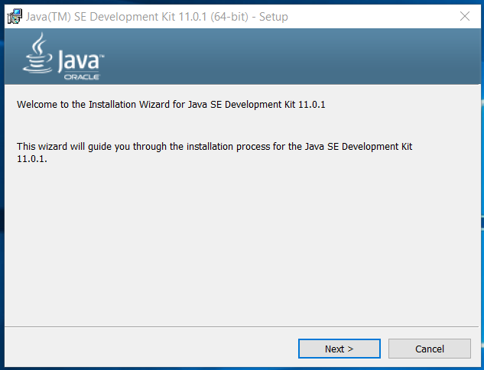

Fig 7.1.2

Click on Next to initiate the installation process. The next screen shows options to select optional features to be installed together. Leave the default options without making any change. We can also change the installation location on this screen if required as displayed in Fig 7.1.3.

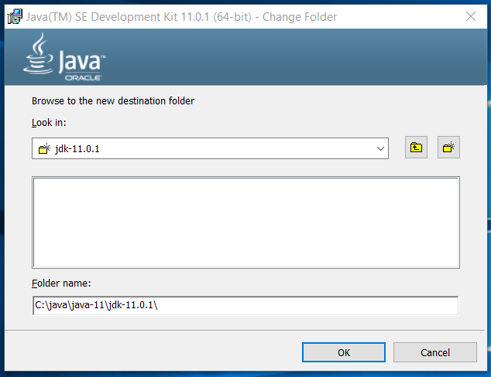

Fig 7.1.3

Now click on Next Button to start the installation. It will show the progress as displayed in Fig 7.1.4.

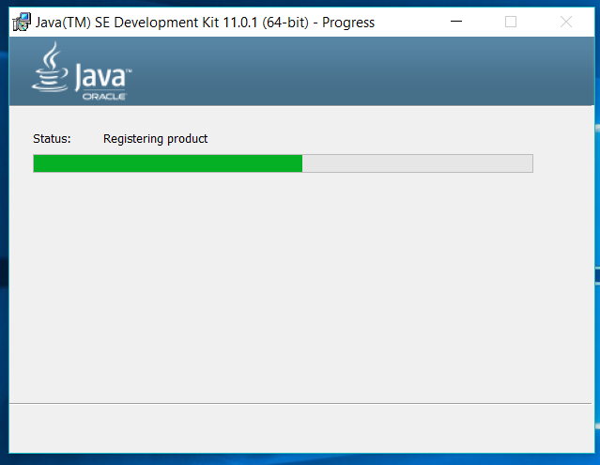

Fig 7.1.4

It shows the success screen after completing the installation as mentioned in Fig 7.1.5.

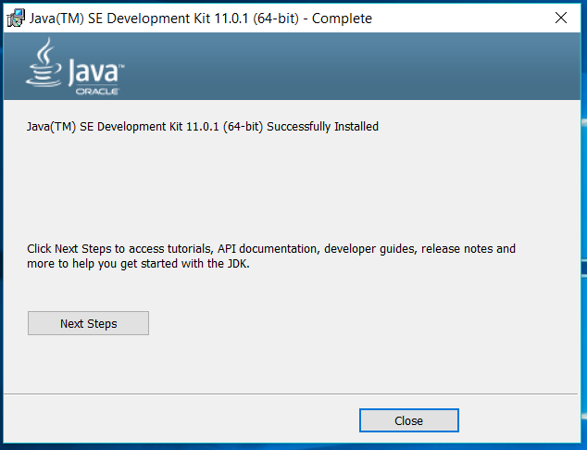

Fig 7.1.5

## Step 3 - Download MySQL Installer for Windows

The MySQL Installer for Windows helps you control the installation process by providing a user-friendly interface. It also guides you through the steps needed to configure MySQL.

Access your [Windows server](https://phoenixnap.com/servers/dedicated) and download the MySQL Installer. A free Community edition MySQL Installer is available from the official page: <https://dev.mysql.com/downloads/installer/>

You are given the option to download either the Web Community version or the Full MySQL package.

Select and download your preferred version. In this example, we selected the **Full MySQL Package** (B).

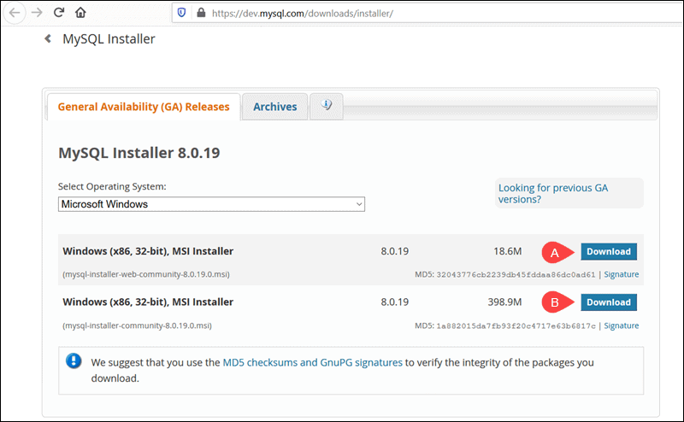

Fig 7.1.6

After selecting a version, you are provided with the option of signing up for a MySQL Community account. If you are not interested, select the **No thanks, just start my download** option at the bottom of the page.

By selecting this option, the download process starts immediately. Once the download is complete, you can execute the MySQL Installer file from the download folder.

It can take a few moments while Windows configures the MySQL Installer and prepares the installation and configuration process.

## Step 4 - Set Up MySQL Installer for Windows

After accepting the Oracle license agreement terms, the first screen you encounter allows you to define which MySQL products are going to be installed. You can choose between several predefined options or create your custom setup type.

After accepting the Oracle license agreement terms, the first screen you encounter allows you to define which MySQL products are going to be installed. You can choose between several predefined options or create your custom setup type.

* **Server Only** is used to install an instance of the MySQL Server and forgo other MySQL products.

In the example below, we select the **Server Only** option and click **Next**.

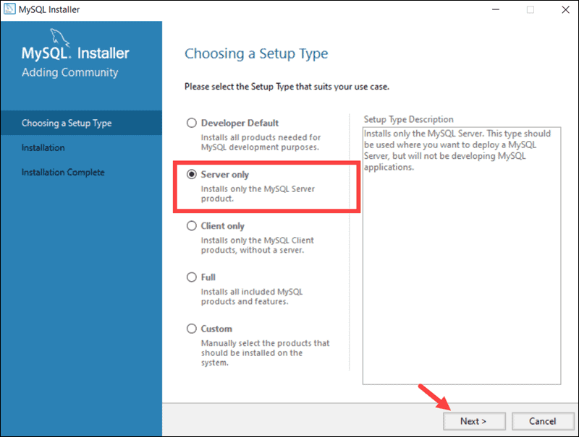

Fig 7.1.7

At this point, the system tries to resolve possible inconsistencies. It might inform you that additional packages need to be installed for the process to continue (e.g., Microsoft Visual C++ 2019 Redistributable Package). You can also run into Path installation inconsistencies if you have previous MySQL installations on your Windows Server.

Luckily the **MySQL Installer auto-resolves issues** and installs the latest binary compatible version of missing software. You are now ready to start the installation process in earnest. Click **Execute** to begin the installation process.

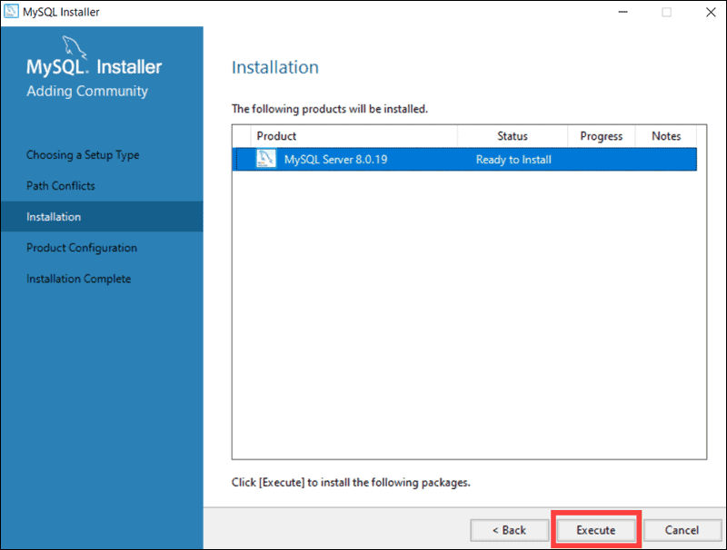

Fig 7.1.8

Once the status of the installation status is labelled as Complete, you are ready to configure the MySQL database.

The MySQL Server 8.0.19 is now ready to be configured. Initiate the process by clicking **Next**.

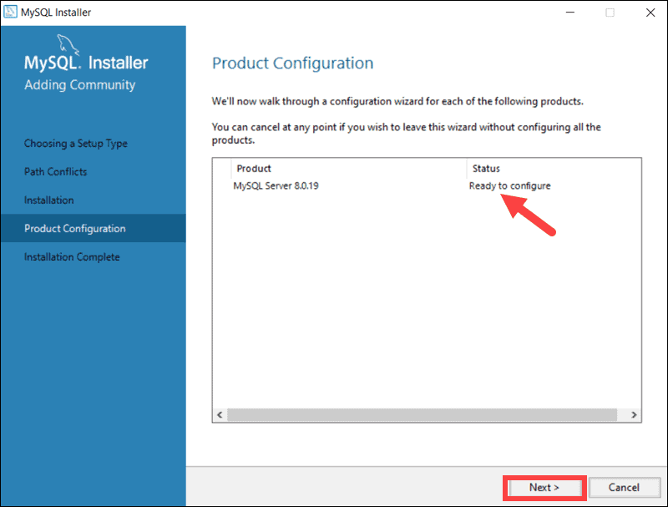

Fig 7.1.9

### High Availability

The first configuration option affects database availability. It allows you to decide if you want to set up a Standalone MySQL Server or an InnoDB server cluster to improve availability. In this instance, we selected the classic, single server option.

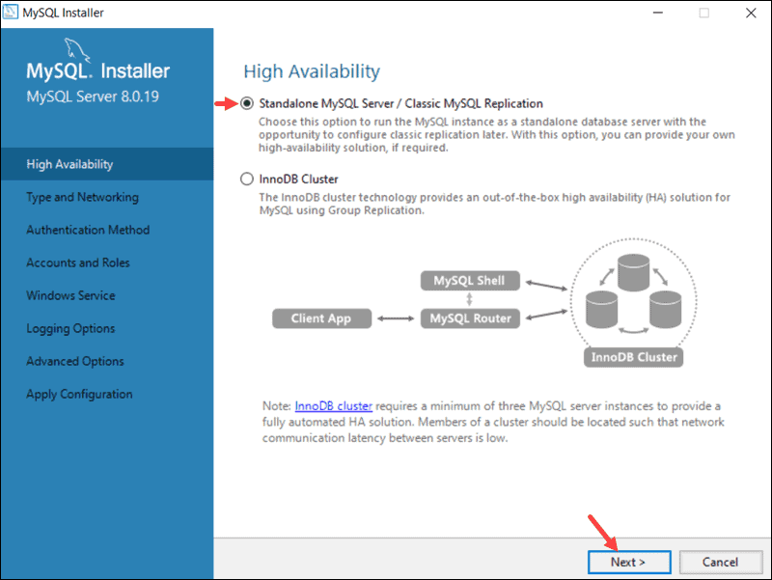

Fig 7.1.10

### Type and Networking

The **Type and Networking** section is used to define several essential features.

The Config Type option lets you choose between three server configuration types. Development Computer, Server Computer, and Dedicated Computer define whether the server is dedicated solely to running your MySQL database or is going to share the underlying system with other applications.

In this example, we decided to create a dedicated MySQL server.

The **Type and Networking** tab can also define the port the MySQL server is listening on. The default setting is port number 3306 and can be changed to suit your needs.

By checking the Show Advanced and Logging Option box, you can set additional logging options at a later stage.

Click **Next**once you’ve selected the options you feel meet your requirements.

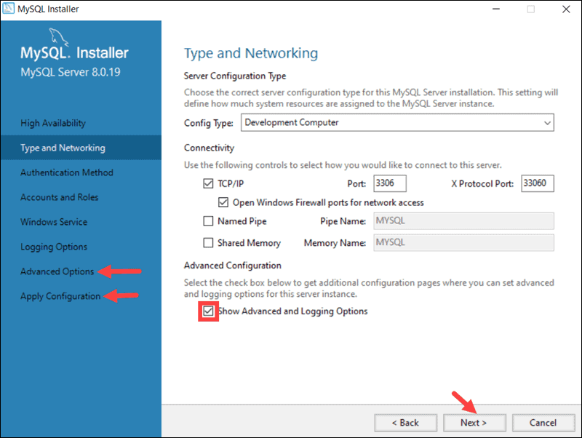

Fig 7.1.11

### Authentication Method

It is possible to choose between two authentication methods, the recommended Strong Password Encryption, and the Legacy Authentication Method. Select the recommended **Use Strong Password Authentication** option.

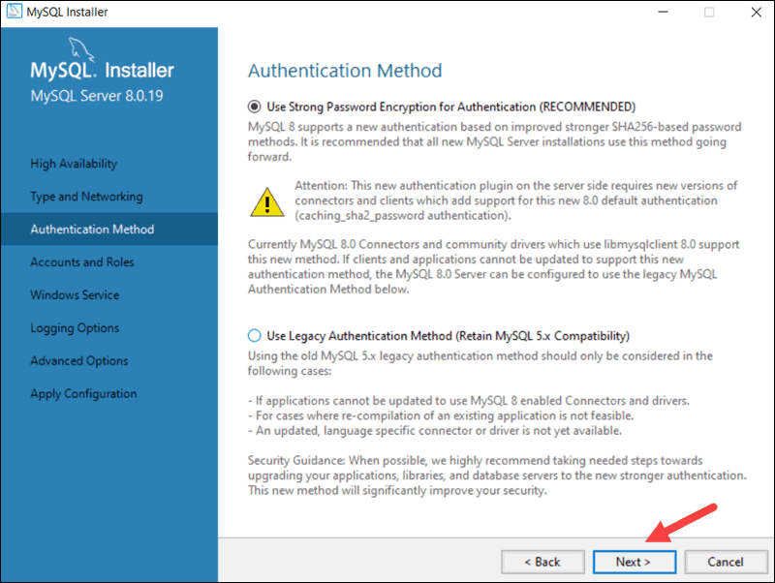

Fig 7.1.12

### Accounts and Roles

You are now prompted to enter a password for your MySQL root user. You can also create additional roles for various users and purposes.

This is only an initial setup, and credentials can be edited once the installation is complete.

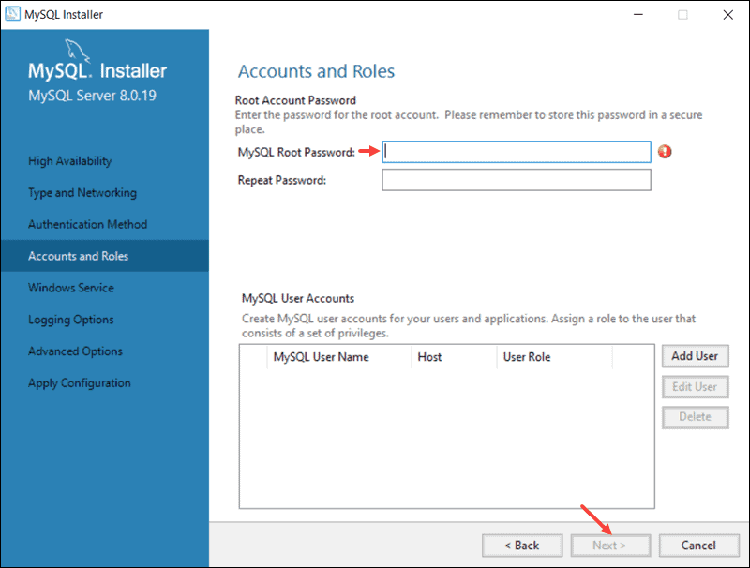

Fig 7.1.13

### Windows Service

By defining MySQL as a Windows Service, it can now start automatically whenever the Windows system boots.

If you decide to start MySQL as an executable application, you would need to configure it manually.

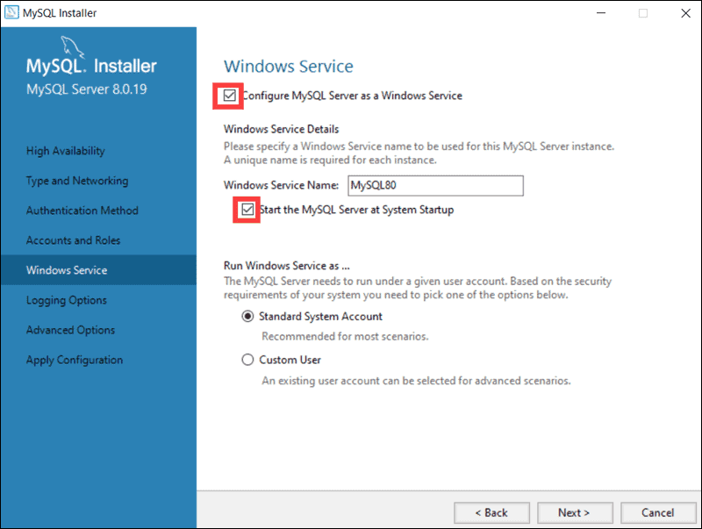

Fig 7.1.14

### Apply Configuration

You have successfully configured the MySQL server and need to confirm for the MySQL Installer to apply the configuration.

An overview of the configurations steps appears on the screen. Click **Execute** to apply the configuration.

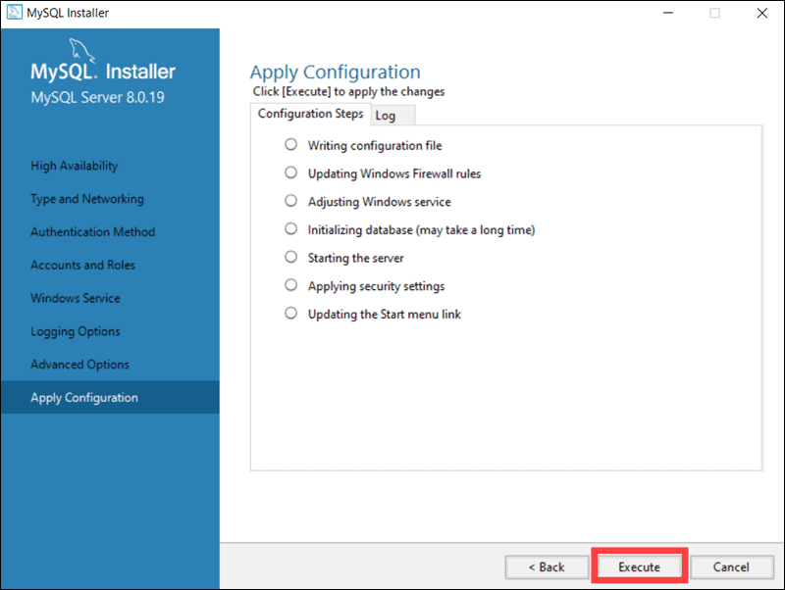

Fig 7.1.15

The system informs once the configuration process is completed. Select **Next** to continue the installation process.

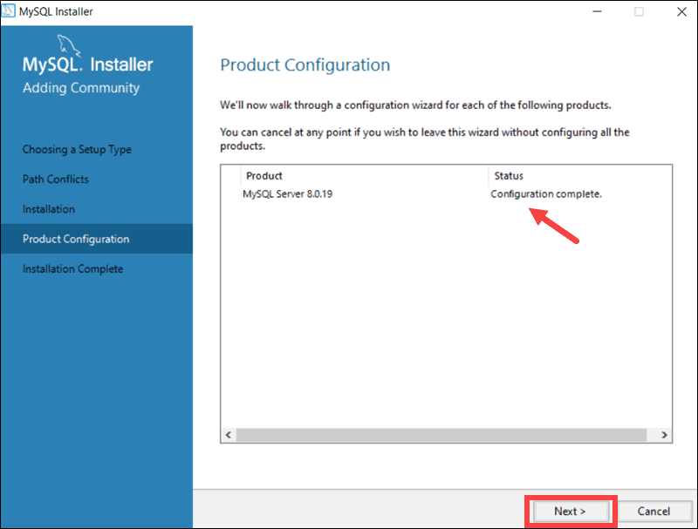

Fig 7.1.16

Click **Finish** to complete the MySQL server installation on Windows.

**Step 5 – Add to path**

We might need to set the environment variable in case the installed JDK and MySQL is not detected by the system. You can follow the below-mentioned steps to set the environment variable.

Right Click -> My Computer(This PC) -> Properties -> Advanced System Settings

The above steps will open the Windows settings panel as shown in Fig 7.1.17.

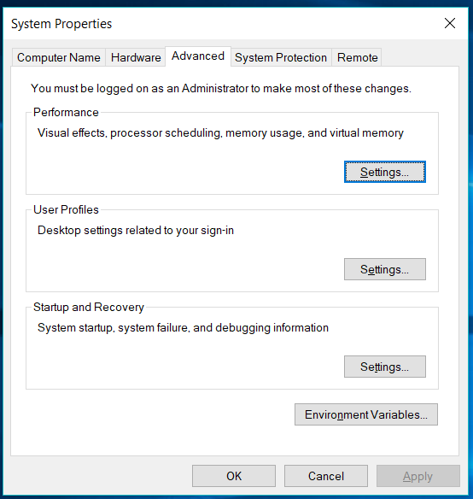

Fig 7.1.17

Now click on Environment Variables, select Path under System Variables section and click on Edit. We need to add the path of installed JDK to system Path.

Click on New Button and add the path to installed JDK and MySQL in which is **C:\java\java-11\jdk-11.0.1\bin; C:\Program Files\MySQL\MySQL Server 8.0\bin;** in our case. Press OK Button 3 times to close all the windows. This sets the JDK 11 on system environment variables to access the same from the console.

**Step 6 – Dump Database**

Now, Open start>cmd

And type **mysql –u root -p**

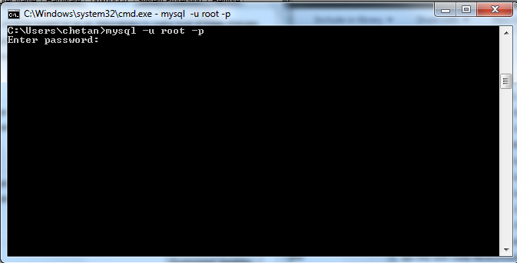

Fig 7.1.18

Write password of mysql server

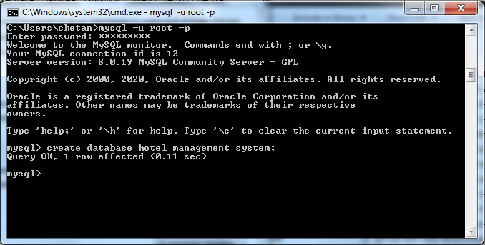

Fig 7.1.19

Now, Write “**create database bookmanagementsystem;**”



Fig 7.1.20

Open project folder and copy the path of **Database.sql**

And write “**mysql –u –p bookmanagementsystem <** copy_path**\database.sql**”

And give password of MySQL

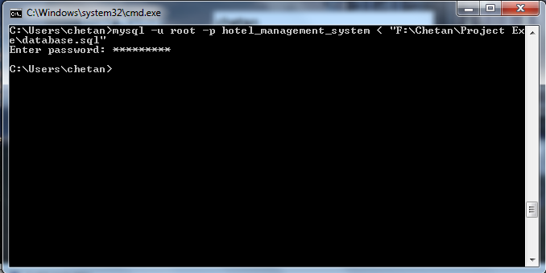

Fig 7.1.21

**Step 6 – Install Apache Tomcat**

## How to Install Apache Tomcat (In 4 Steps)

When setting up a new tool, it pays to take your time and make sure you’re starting off on the right foot. With the following four steps, you can feel confident as you launch Apache Tomcat.

### Download the Prerequisite Software

Before you start downloading Tomcat, you will first need either [Java Development Kit (JDK)](https://www.oracle.com/java/technologies/javase-jdk11-downloads.html) or [Java Runtime Environment (JRE)](https://www.oracle.com/technetwork/java/javase/downloads/jre10-downloads-4417026.html). These tools can help you add Java to your Windows environment variables, and thus enable you to use Apache Tomcat.

Once you’ve finished the download, head over to the [Apache Tomcat home page](https://tomcat.apache.org/). There, you’ll find options to download various versions of the software:

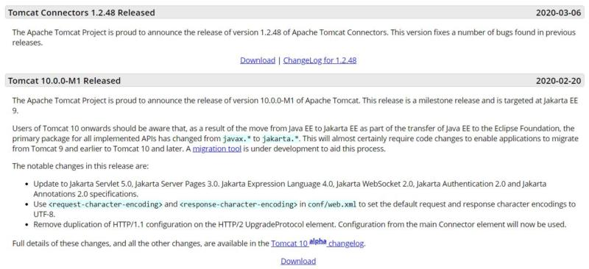

Fig 7.1.22

Each release explains what changes have been made to it. As added guidance, Tomcat itself offers a page providing details about which [build supports particular Java specifications](https://tomcat.apache.org/whichversion.html).

For simplicity’s sake, we’re going to download Apache Tomcat 10. You can get the software as either a .zip file or an .exe file.

### Choose Your Components

This is when the setup process really begins. Go back to the Apache Tomcat home page, and download the Windows Installer (either 32- or 64-bit as needed):

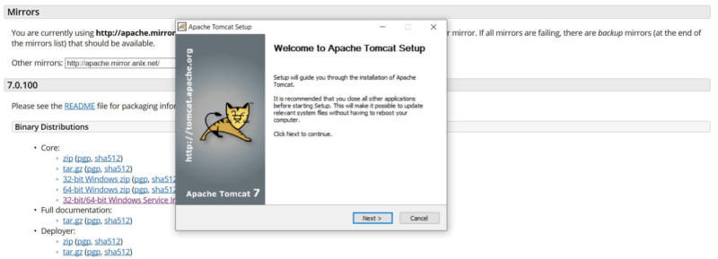

Fig 7.1.23

Once the download is complete, click on Next. Then you’ll need to agree to the License Agreement.

Apache Tomcat offers a highly customizable installation process. In fact, you’re able to omit the various add-ons that can be included by choosing whether you want a normal, minimal, full, or custom Windows Service install:

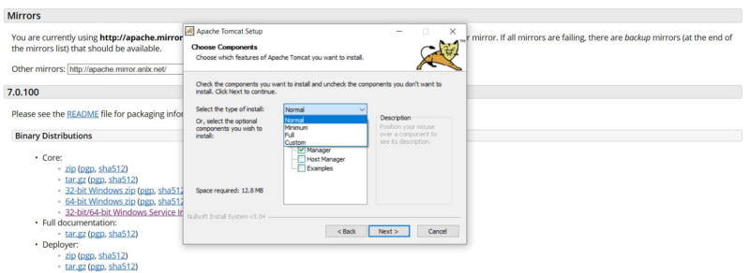

Fig 7.1.24

These optional items include:

* Start menu items, which enable you to create a start menu group.
* Documentation bundle, which also includes information specific to the Servlet container.
* Jasper, a JSP page compiler.
* Native web server connectors.
* Manager, which installs the Tomcat Manager administrative application.
* The Host Manager that enables you to create, deletes, and administers virtual hosts through Tomcat.
* Examples, which provides you with illustrative Servlet and JSP web applications.

Once you’ve made your decision about which elements you’d like to include, you can click on Next again. The installation wizard will then take you to the configuration options.

### Check Your Configuration

On the configuration screen, you’ll again have some choices as to how you’ll customize your Apache Tomcat installation. Let’s take a detailed look at what the options include:

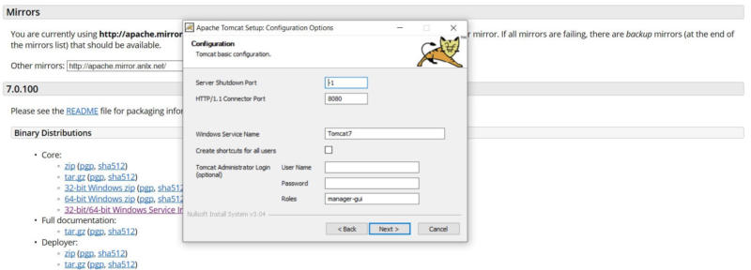

Fig 7.1.25

If you’re unsure about what each field means, here are brief descriptions of each:

* **Server Shutdown Port** enables anyone who contacts the server locally through the default 8005 port with the command ‘shutdown’ to terminate its running web applications.
* **HTTP/1.1 Connector Port** is Tomcat’s server port, and is used to show HTTP content.
* **Windows Service Name** tells you what Tomcat will be labeled as when it runs.

It’s worth noting that it’s okay to keep things as they are, as most of these fields can safely be left to their default settings.

Once you are done with the basic configuration process, you’ll need to identify the installation path of your Java 8 or JRE folder:

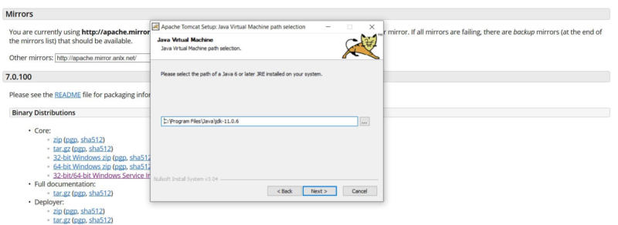

Fig 7.1.26

Finally, the wizard will ask you to confirm the destination folder for your Apache Tomcat installation. When you’ve finished with that, you can complete the process.

### Test Tomcat Out

At the very end of the installation process, you’ll have the option to run Tomcat and display the readme file:

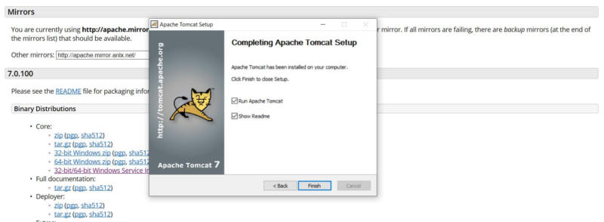

Fig 7.1.27

Now that you’ve installed Apache Tomcat, you’ll want to be certain that it’s been property set up. After all, what’s the point of having your new Java Servlet only to end up not being able to use it?

Fortunately, you can do this easily by running Tomcat and entering “localhost:8080” into the address bar in your browser of choice. If your installation has been successful, you should see a page similar to this one:

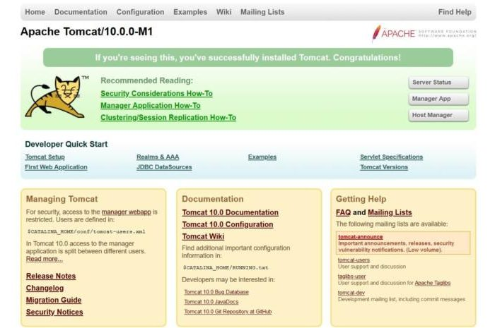

Fig 7.1.28

At this point, you’re done! Now you’re ready to go ahead and explore Java with Apache Tomcat.

Now you can run your war file.

**7.2 Do and Don’ts**

* Install JDK 11
* Install Mysql 8.0.19
* Install Apache Tomcat
* Dump database.sql in MySQL

**8. Conclusion**

The project entitled Online Book Store was completed successfully. The system has been developed with much care and free of errors and at the same time it is efficient and less time consuming. The purpose of this project was to develop a web application and an android application for purchasing items from a shop. This project helped us in gaining valuable information and practical knowledge on several topics like designing web pages using html & css, usage of responsive templates, designing of android applications, and management of database using MySQL. The entire system is secured. Also the project helped us understanding about the development phases of a project and software development life cycle. We learned how to test different features of a project. This project has given us great satisfaction in having designed an application which can be implemented to any nearby shops or branded shops selling various kinds of products by simple modifications. There is a scope for further development in our project to a great extend. A number of features can be added to this system in future like providing moderator more control over products so that each moderator can maintain their own products. Another feature we wished to implement was providing classes for customers so that different offers can be given to each class. System may keep track of history of purchases of each customer and provide suggestions based on their history. These features could have implemented unless the time did not limited us.

After having detail study on online book shopping, we can see a great change in the behavior of people in many managers like their attitude, buying pattern. In earlier times people use to do manual shopping but now as time changed, people are becoming busy and due to which technology has brought a new revolution i.e. online shopping. As we started doing survey, it came to in notice that young age group people i.e. 15-30 uses of prefer online shopping because it is time and energy saving. But middle age group does not prefer much because they have wrong perception that by seeing the product one can get the goods of proper quality. And even some people does not prefer using plastic money i.e. credit cards. But online shopping has a great future but to be successful it is necessary to spread awareness about its benefit.

**9. Limitations and Future Works**

The project has a very vast scope in future. The project can be implemented on intranet in future. Project can be updated in near future as and when requirement for the same arises, as it is very flexible in terms of expansion. With the proposed software of database Space Manager ready and fully functional the client is now able to manage and hence run the entire work in a much better, accurate and error free manner.

The following are the future scope for the project:

* Should be added payment gateway
* Can be added inventory management system
* Can be added multiple branches
* Can be added multilingual to this site
* Many features can be added this project to make it more robust.
* Want to Increase facilities of this project.
* Want to add printing option.
* Want to develop graphical design.
* Want to publish this website in online.
* Want to remove all the limitation

**10. Bibliography and References**

[Java Documentation - Get Started (oracle.com)](https://docs.oracle.com/en/java/)

[Java Tutorial | Learn Java - javatpoint](https://www.javatpoint.com/java-tutorial)

[Java Tutorial (w3schools.com)](https://www.w3schools.com/java/)

[SQL Tutorial - Tutorialspoint](https://www.tutorialspoint.com/sql/)

[Stack Overflow - Where Developers Learn, Share, & Build Careers](https://stackoverflow.com/)

[YouTube](https://www.youtube.com/)

Herbert Schildt “Java: The Complete Reference” Tata McGraw-Hill Publishing Company Limited, Seventh Edition